**Government of the People’s Republic of Bangladesh**

**Ministry of Water Resources**

**Bangladesh Water Development Board**

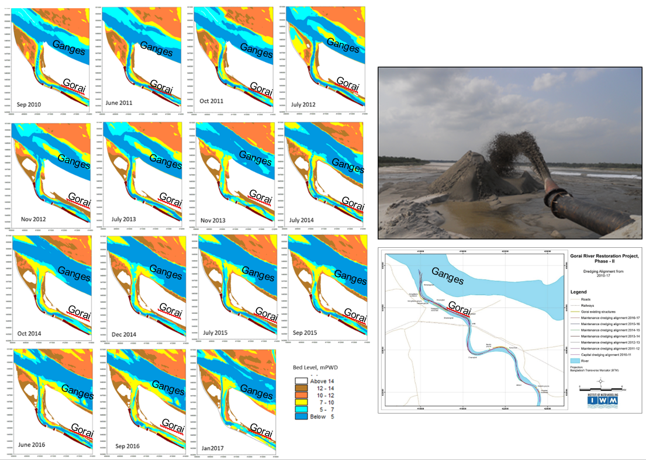

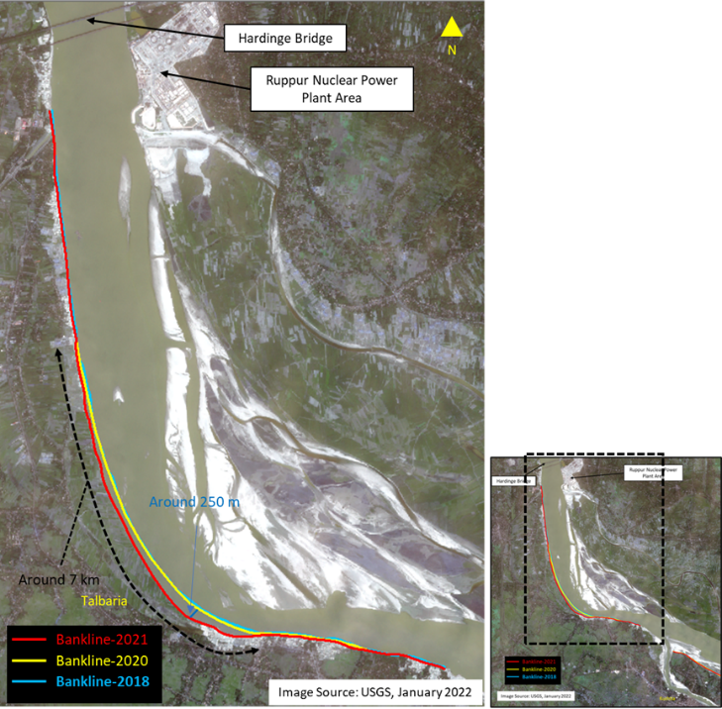

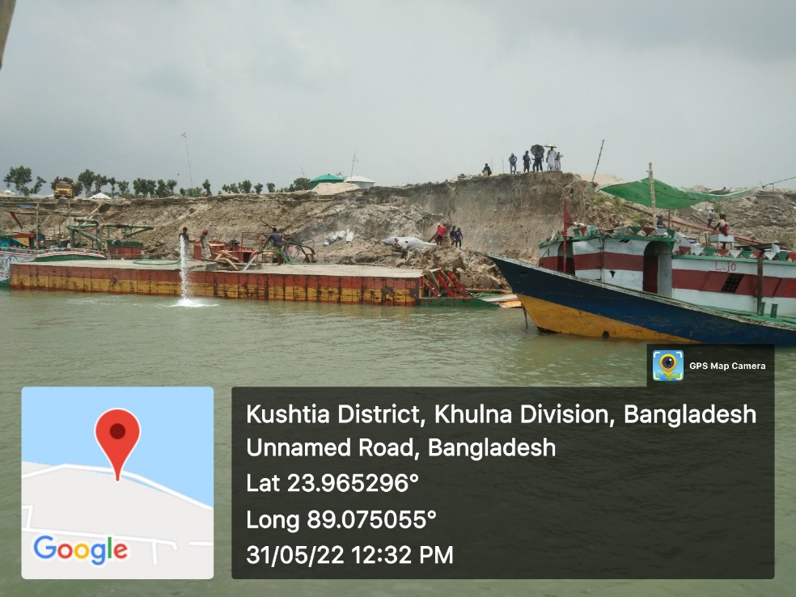

**MATHEMATICAL MODELLING STUDY FOR SUSTAINABLE MANAGEMENT OF GORAI RIVER BASIN INCLUDING OFFTAKE**

**Technical Report -1 (Revised)**

**Protection of Talbaria area of Mirpur Upzilla & Kamorkandi area of Shelaidah union of Kumarkhali Upazilla in Kushtia district from the erosion of Padma River**

**October 2022**

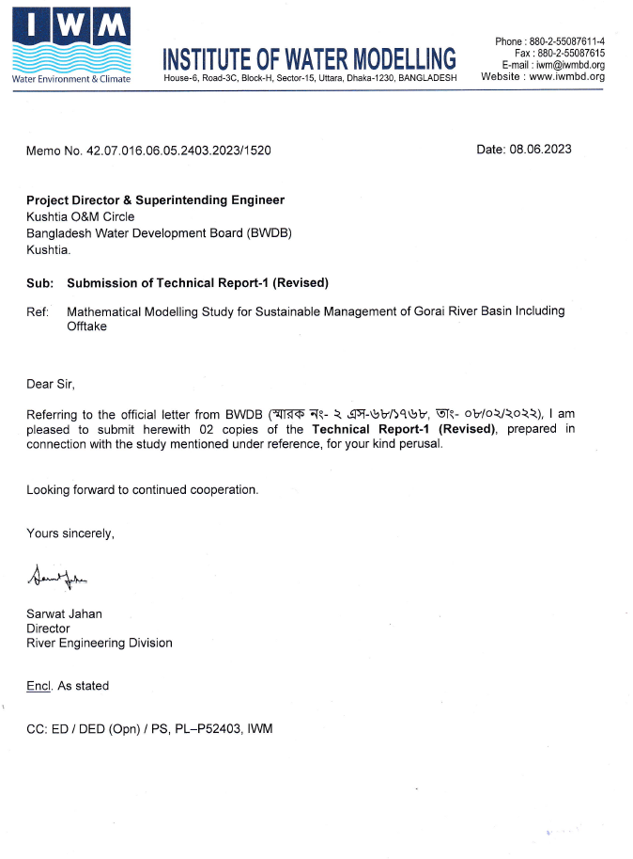

**TABLE OF CONTENTS**

LIST OF FIGURES ii

LIST OF TABLES iii

1 INTRODUCTION 1-1

1.1 Background 1-1

1.2 Objectives 1-1

2 APPROACH AND METHODOLOGY 2-1

2.1 Approach and Methodology 2-1

2.2 Application of Mathematical Modelling Technology 2-1

2.3 Mathematical Modelling Tool 2-3

3 AN OVERVIEW OF THE EROSION PROBLEM AREA 3-1

3.1 General 3-1

3.2 Hydrology 3-2

3.3 Morphological setting 3-3

3.4 Sediment transport 3-3

4 HISTORICAL TREND AND EXISTING DATA ANALYSIS 4-1

4.1 Discharge Data 4-1

4.2 Water Level 4-3

4.3 Planform analysis 4-4

4.2.5 Sediment transport 4-6

5 MODEL SETUP, DEVELOPMENT AND CALIBRATION CONSIDERATIONS 5-1

5.1 2D Morphological Model of GGRS 5-1

5.2 Model Calibration and Validation 5-1

6 EVALUATION OF THE SIMULATED OPTIONS 6-1

6.1 Description of Model Simulations of Talbaria Bank Protection Works 6-3

6.1.1 Base condition 6-3

6.1.2 Effectiveness of a Series of Groynes (Option-9) 6-5

6.1.3 Effectiveness of Bank Revetment and Flow Divider (Option-11) 6-11

6.2 Probable Morphological Condition near Shelaidah 6-22

7 RECOMMENDATIONS 7-1

**ANNEXURES**

APPENDIX-A DETAIL DESIGN REPORT

APPENDIX-B COST ESTIMATE

APPENDIX-C CORRESPONDENCES

APPENDIX-D ENVIRONMENTAL ASSESSMENT

# LIST OF FIGURES

**Figure 2.1** Generated Curvilinear Grid and Bathymetry of the Ganges-Gorai River System 2-2

**Figure 3.1** Bank line migration of the Ganges River at Talbaria 3-1

**Figure 3.2** Bank Erosion at Talbaria 3-2

**Figure 3.3** Temporary Bank protection works at Bahalbaria, Talbaria, Kushtia 3-2

**Figure 4.1** Monthly average discharges of the Ganges River at Hardinge Bridge 4-1

**Figure 4.2** Yearly Maximum and minimum discharges of the Ganges River at Hardinge Bridge 4-1

**Figure 4.3** Monthly average discharge variation of the Gorai River at Gorai Railway Bridge 4-2

**Figure 4.4** Flow diversion to the Gorai for 2021-2022 4-2

**Figure 4.5** Maximum, minimum and average Water Level of the Ganges at Hardinge Bridge 4-3

**Figure 4.6** Maximum, minimum, and average water level of Gorai River at Gorai Railway Bridge 4-3

**Figure 4.7** Measured Water Levels at different locations of Gorai River 4-4

**Figure 4.8** Ganges right bank shifting upstream of Gorai offtake 4-4

**Figure 4.9** An overview for the changes of Gorai Offtake width 4-5

**Figure 4.10** Bank erosion accretion in the Ganges River within the study area 4-5

**Figure 4.11** Char erosion- accretion in the Ganges within study area. 4-6

**Figure 4.12** Measured suspended sediment concentrations at different locations within the study area 4-6

**Figure 4.13** Sediment rating curves of the Ganges River at Hardinge Bridge 4-7

**Figure 4.14** Sediment rating curves of the Gorai at Gorai Rail Bridge 4-7

**Figure 5.1** Calibration of Discharge through Gorai Offtake. 5-1

**Figure 6.1** Interventions simulated in the 2D morphological model. 6-3

**Figure 6.2** Surveyed Data of the Ganges and the Gorai River for the year 2021 6-4

**Figure 6.3** Interpolated Bathymetry Developed for the 2D morphological model. 6-5

**Figure-6.4** Initial condition bathymetry plot with proposed groynes 6-6

**Figure 6.5** Morphological development at Talbaria after fourth monsoon (End of November) 6-7

6-7

**Figure 6.6** Cross sectional change (Typical) at Gorai offtake due to the proposed series of groynes after fourth monsoon. 6-7

**Figure 6.7** Typical view of cross-sectional change between proposed Groynes 11-12 6-8

**Figure 6.8** Cross section changes at downstream of groyne-2 at the end of simulation 6-8

**Figure 6.9** Cross section changes at downstream of groyne-12 at the end of simulation 6-9

**Figure 6.10** Cross section changes at downstream of groyne-15 at the end of simulation 6-9

**Figure 6.11** Peak Flow Velocity vectors for base condition (1 in 100 year return period) 6-10

**Figure 6.12** Peak Flow Velocity vectors with proposed groynes (1 in 100 year return period) 6-10

**Figure 6.13** Simulated sediment discharge through Gorai Offtake with proposed groynes 6-11

**Figure 6.14** Option-11 superimposed over satellite image of April-2022 6-12

**Figure 6.15** Option-11 superimposed on initial bathymetry of November-2021 6-13

**Figure 6.16** 2D plot of morphological development at the study area with Talbaria revetment and Gorai Offtake flow divider (option-11) 6-14

**Figure 6.17** Probable Cross-section of Ganges River with Talbaria revetment and Gorai Offtake flow divider (option-11) 6-15

**Figure 6.17 (contd.)** Probable Cross-section of Ganges River with Talbaria revetment and Gorai Offtake flow divider (option-11) 6-16

**Figure 6.18** Cross Sectional change after simulation at the Gorai Offtake in option-11 6-17

**Figure 6.19** Sediment discharge through the Gorai for option-11 6-17

**Figure 6.19** Option-12 incorporating dredging near Talbaria in the Ganges 6-19

**Figure 6.20** Simulation results (probable bed levels) of Option-12 6-20

**Figure 6.21** Typical section showing dredged channel silted up. 6-21

**Figure 6.22** Simulated Probable Cross-sections (after implementation of Option-11) near Shelaidah for Average Flood Event 6-22

**Figure 6.23** Simulated Probable Bed Levels (after implementation of Option-11) near Shelaidah 6-23

**Figure 7.1** Implementation Plan of Proposed Revetment at Talbaria 7-2

**Figure 7.2** Proposed and Existing Revetment near Komarkandi of Shelaidah 7-2

# LIST OF TABLES

Table 6.1 Simulated Options 6-1

Table 6.2 Probable discharge scenarios through the Ganges and Gorai 6-11

Table 6.3 Probable Discharge diversion through the Gorai 6-11

Table 6.4 Discharge condition during simulation in option-11 6-18

Table 6.5 Discharge diversion through the Gorai 6-18

Table 6.6 Discharge condition during simulation in Option-11 6-21

Table 6.7 Discharge diversion through the Gorai 6-21

Table 7.1 Decision matrix for selecting most suitable option for Talbaria protection and dry season flow through Gorai Offtake 7-1

# INTRODUCTION

## Background

The Gorai River is one of the major distributaries of the Ganges River at the right bank and important provider of freshwater inflows to South-West region of Bangladesh. The length of the river is around 199 km, and the area of the Gorai River catchment is 15160 km². The Gorai discharges into the Bay of Bengal through the Madhumati and Baleswar Rivers. The Madhumati is connected with the Nabaganga River at Bardia point. This is the drainage path of the Gorai water, which now reaches the Bay mainly via the Pussur and Sibsa Rivers (Islam and Gnauck, 2011).

In order to revive the flow of the Gorai, dredging of 20 to 30 km of the Gorai River from offtake to downstream was executed in the past in different phases. Several years ago, Gorai River Restoration Project, Phase-II was implemented which constituted dredging of the off-take area and monitoring of hydrodynamic, morphological and salinity intrusion in the downstream of Gorai River. The overall objectives of the project included prevention of environmental degradation in the South-West region, specifically around Khulna, the coastal belt and in the Sundarbans. Prior to GRRP-II, Phase-I was launched in 1998. During this period, the Gorai River was dredged starting from off-take to 20 km and it continued for three consecutive years: 1998, 1999 & 2000 under a Pilot Priority Works (PPW). In the following year, a Feasibility Study was carried out by DHV-Haskoning & Associates and they recommended river training works which would guide more water into the Gorai during lean season.

The essential requirement of the present study is to increase the dry season flow through the Gorai River and its distributaries (according to ToR). With this view, IWM has been conducting the hydro-morphological investigation of the Ganges and the Gorai River so that suitable option for flow augmentation through the Gorai can be achieved. A contract has been signed on the 1st July 2021 between IWM and BWDB for the study titled “Mathematical modelling study for sustainable management of Gorai River basin including Offtake”. However, during course of the study, it was observed that severe bank erosion at right bank of the Ganges at Talbaria has been taken place and the trend posed serious threat to the bank. Conditions were so severe that 7 to 10 km reach at right bank of Ganges was eroded after passing monsoon of 2021. Accordingly, to protect the vulnerable area from further bank erosion and as per request from the BWDB Officials (স্মারক নং- ২ এস-৬৮/১৭৬৮, তাং- ০৮/০২/২০২২), this technical note has been prepared incorporating the structural interventions needed to abate bank erosion at Talbaria and simultaneously increasing dry season flow through Gorai Offtake. This document, Technical Report-1, is prepared mainly focussing on the requirement of bank protection, design and layout of river training measures to be undertaken at Talbaria area.

## Objectives

The objectives of the main study are:

* To develop hydro-morphological baseline conditions of the study area.
* To assess maximum available water resources that can be driven through Gorai River and net flow received from the Bay of Bengal in the Gorai river basin area;
* To assess hydrodynamic, morphological, sedimentation and salinity intrusion scenario for integrated and sustainable management of water resources at the Gorai River basin.
* To find out appropriate solution to channel closing tendency during dry season through suitable structural intervention at the offtake of Gorai River using mathematical modelling technique.
* To identify suitable locations for interventions if necessary.
* To provide detail design of dredging/excavation re-excavation of rivers / khals / canals and all types of proposed interventions / infrastructures.
* To establish connectivity between rivers / khals / canals in Gorai River basin.
* To identify the existing infrastructures those, need to be rehabilitated / dismantled.
* To develop integrated river management plan for the Gorai River basin.

Whereas the main objectives of the present assignment regarding bank protection works at Talbaria are:

* To select and optimize suitable bank protection structures at Talbaria by mathematical modelling.
* To find out the length, location, and orientation of the selected bank protection structure.
* Provide design/drawing of the recommended bank protection works.
* Provide tentative cost estimates of the proposed works.

Due to exigency arisen from the field and upon special request made by the Project Director (PD), as an additional work beyond the scope of the approved ToR of the present study, this technical note is prepared focusing the above-mentioned objectives only so that immediate emergency protection work can be started on the basis of detail investigation of the existing and probable hydro-morphological condition of the Ganges-Gorai River system at Talbaria.

# APPROACH AND METHODOLOGY

## Approach and Methodology

The approach of the present study is to update and apply the two-dimensional hydro-morphological model of the Ganges-Gorai River system, that was developed during the previous study.

In order to investigate the suitable river training/bank protection works of the Ganges at the right bank at Talbaria, available bathymetry, planform, cross sections, discharge, water level, satellite images etc. of the Ganges and Gorai River have been collected, compiled and analysed, prior to modelling. Recent bank erosion assessment has been done and its trend has also been analyzed using available previous data near the Ganges right bank at Talbaria. Field visit, discussion with local people has been accomplished to have existing condition of the erosion prone area. Based on the existing and past data analysis, past study reports and model generated outputs, protection measures have been planned. Different design options of the proposed river training and bank protection works have been simulated in the 2D morphological Ganges-Gorai model, and its performances have been evaluated. The outputs of the model and subsequent findings of various options have been discussed time to time with field office engineers and professionals of BWDB.

## Application of Mathematical Modelling Technology

Mathematical Modelling, backed up by survey and investigation have been carried out to obtain clear understanding of the prevailing hydro-morphological processes in the Ganges-Gorai River system encompassing the study area. The study area covers a length of about 50 km of the Ganges (from around 17 km upstream of the Gorai Offtake up to around 33 km downstream of the same upto Sengram), while the length of the Gorai is around 30 km from its offtake.The model is calibrated and verified with measured data of 2021. Developed 2D Morphological model is used to investigate the effectiveness of the proposed bank protection works at Talbaria. **Figure 2.1** shows the generated curvilinear grid and bathymetry used for the 2D morphological model.

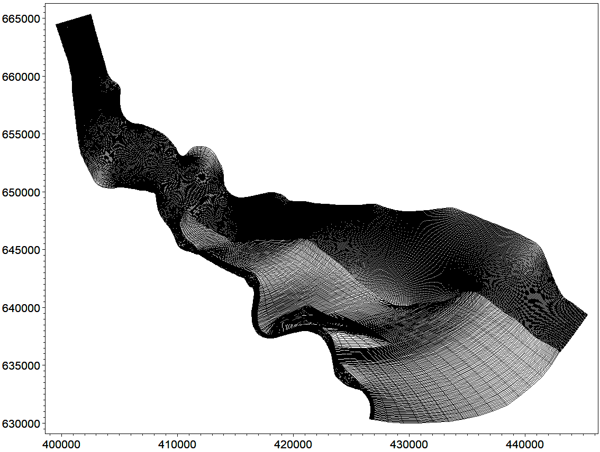

Talbaria

Kushtia Sadar

Janipur

Sengram

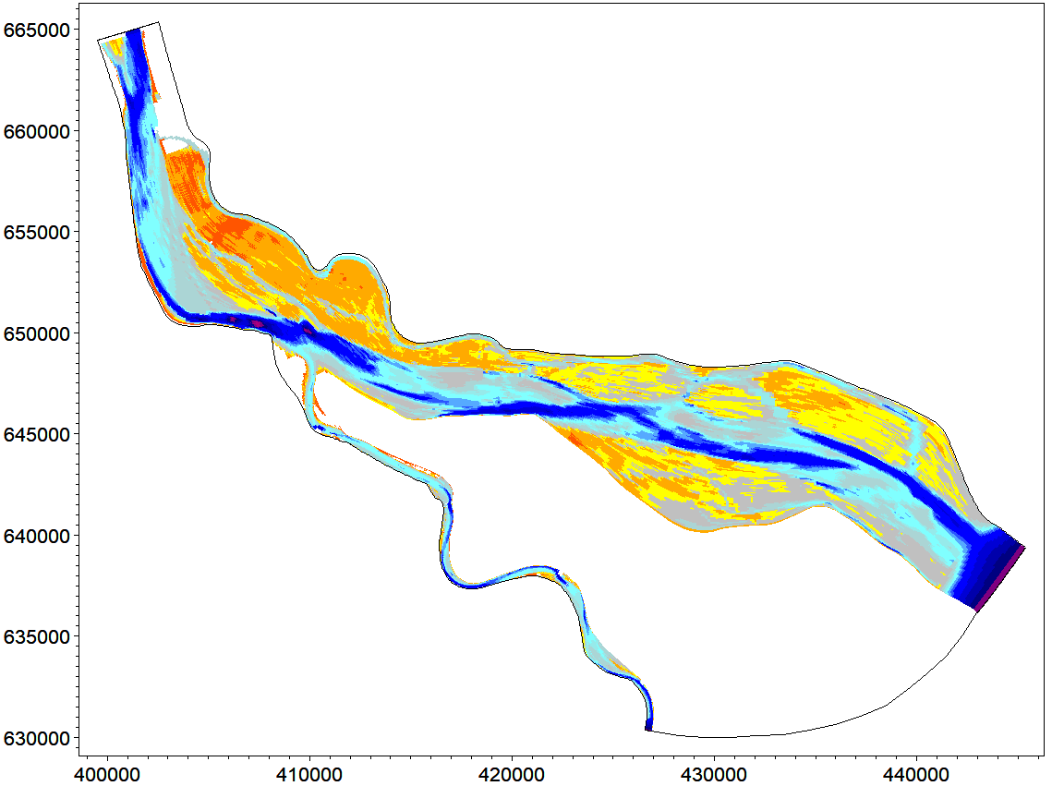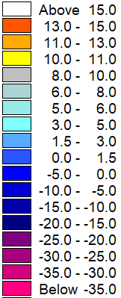

Bed Level (mPWD)

Talbaria

Kushtia Sadar

Janipur

Sengram

**Figure 2.1** Generated Curvilinear Grid and Bathymetry of the Ganges-Gorai River System

## Mathematical Modelling Tool

Mathematical modelling tool, MIKE 21C of the MIKE series (DHI-Water and Environment) have been chosen for this present study. MIKE 21C applies curvilinear computational grid; it incorporates fully unsteady flow, bed load as well as suspended load including dynamic bed level changes through simple sediment continuity, updates the planform through bank erosion model and includes the computation of the secondary currents, and thus provides 3D effects for a 2D model.

# AN OVERVIEW OF THE EROSION PROBLEM AREA

## General

As mentioned earlier, Talbaria lies at right bank of the Ganges, upstream of Gorai Offtake. Recent field conditions showed severe bank erosion at right bank near Talbaria for a stretch of about 7 to 10 km reach. **Figure 3.1** shows bank line migration derived from analysis of historical satellite images (USGS 2018, 2020 and 2021) where the erosion prone area is clearly visible. To control further propagation, BWDB is already implementing temporary bank protection works by using geo-bags (**Figure 3.2** and **Figure 3.3**) on urgent basis. However, long term solution is needed to reduce this erosion tendency permanently.

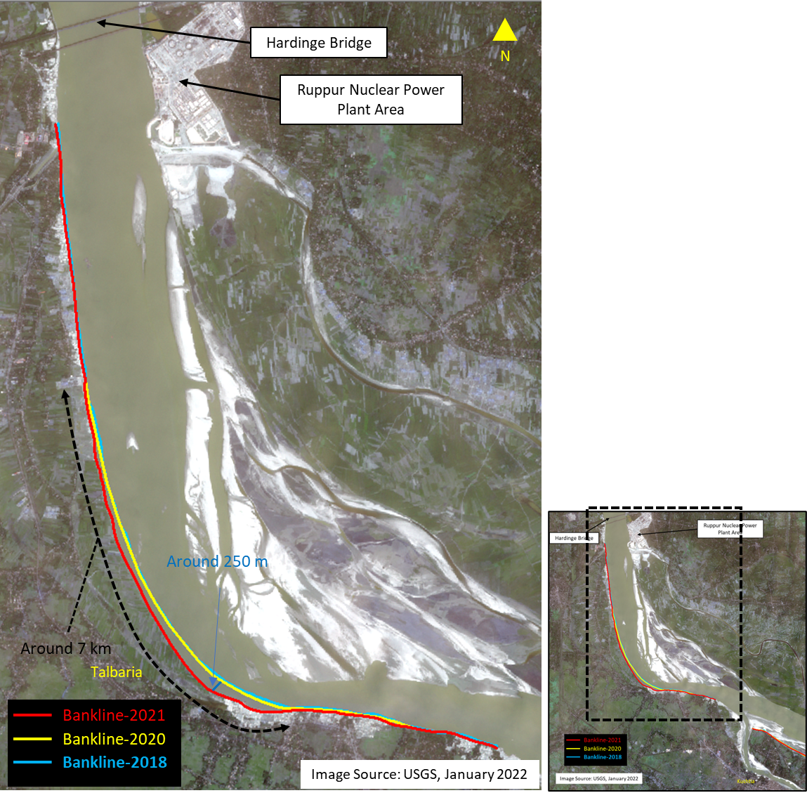

**Figure 3.1** Bank line migration of the Ganges River at Talbaria

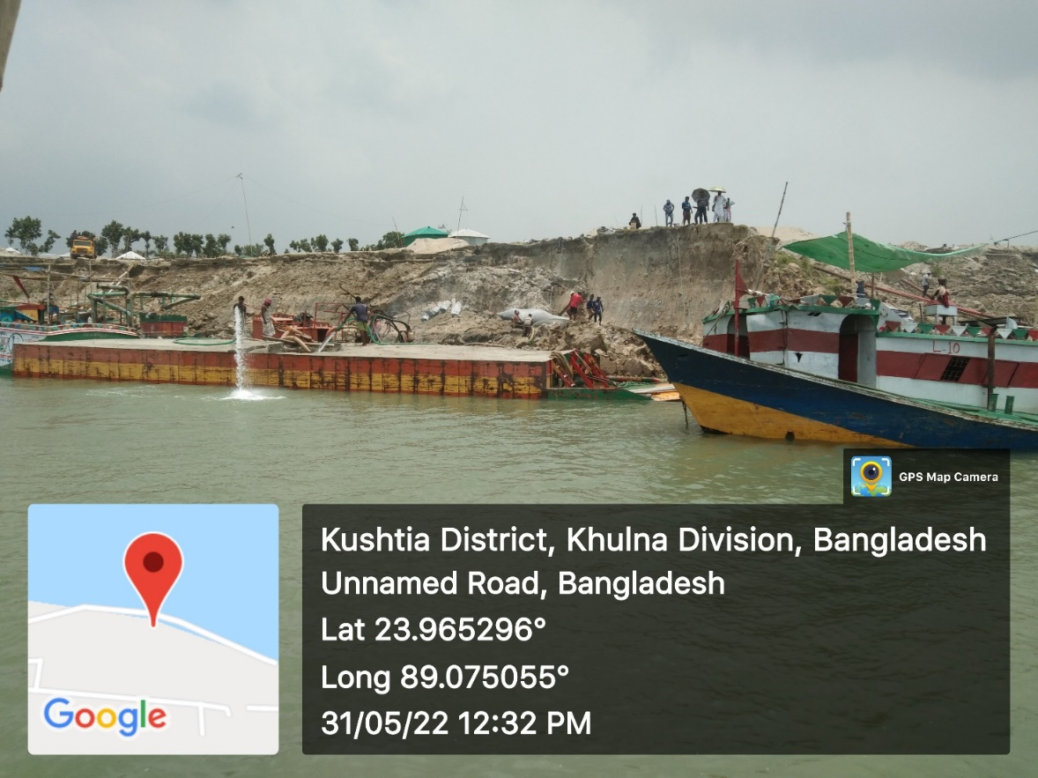

**Figure 3.****2** Bank Erosion at Talbaria

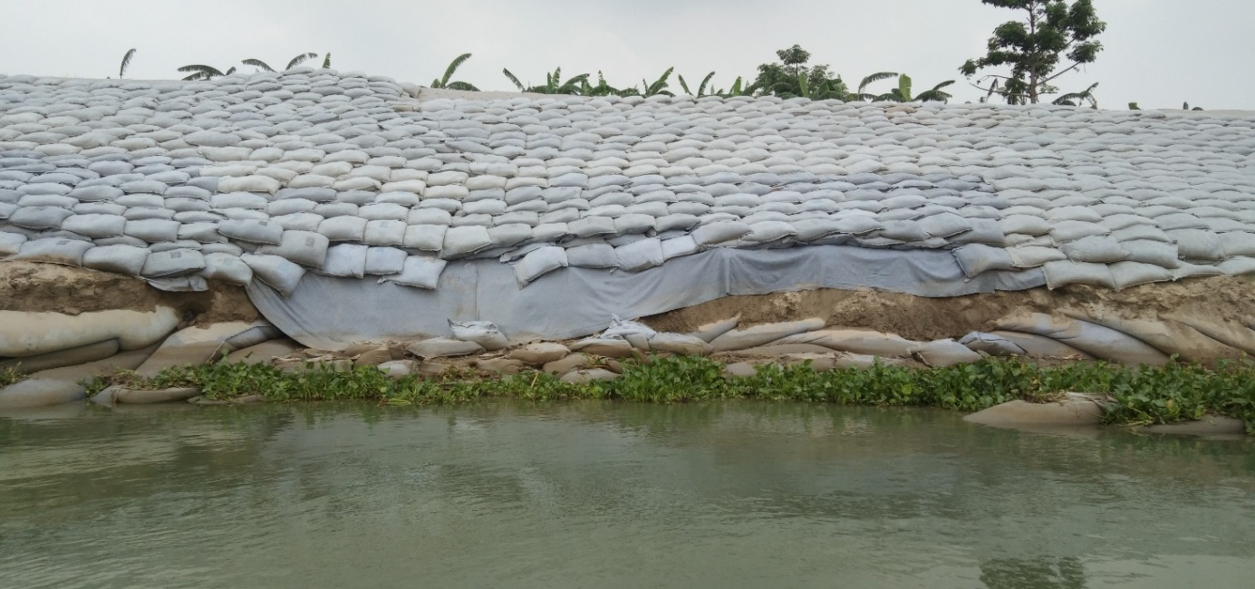

**Figure 3.3** Temporary Bank protection works at Bahalbaria, Talbaria, Kushtia

## Hydrology

The Gorai River is mainly dependent on the Ganges flows both in the dry and wet seasons. The decline in the post-Farakka dry season Ganges flow resulted in a reduction in the dry season water levels in the Ganges. It caused an increase in the bed level at the Gorai mouth from about 4 m PWD in 1964 to 7 m PWD in 1989. It is revealed from the feasibility study of GRRP that peak water levels along the Gorai River vary from 13.5 mPWD at Gorai Railway Bridge to 4.8 mPWD at Bardia. Flow through the Gorai River as measured at the Gorai Railway Bridge varies from 0 to 8,500 m3/s. The annual flow volume during the post- Farakka period have been found to exhibit a significant declining trend. It is also reported that the Gorai has stopped flowing within the dry season every year since 1988. The Gorai offtake was seen to have opened sometime between mid-May and mid-June and opened between end of December to end of January. The reduction in the mean monthly discharges compared to the pre-Farakka period from November to May is also quite significant (Inception Report’ 2021).

## Morphological setting

The Ganges system in Bangladesh has some unique characteristics in respect of its fluctuating discharge, sediment load, role of tributaries of the delta. The various river training works both at upper (West Bengal) part and Bangladesh part exert large influence on the fluvial dynamics of the river. Apart from the 2.64 km long Farakka barrage, which was built across the river during 1962-1971 in India, the flood-control embankments, bank revetment, spurs are all combined to interrupt the fluvial dynamics. The erosion along the bank of the Ganges is the phenomenon of the Monsoon months (June –September), and it has two distinct phases: the pre-flood and post-flood erosion. The peak discharge of the river may be to the tune of 77,000 cumec, as was observed in September 1998. The fast-moving current during the rising stage of flow removes unconsolidated sediment from the base of the shelving bank, which ultimately collapses. The post-flood erosion is related to the effluent flow of the ground water into the river. This occurs during the falling stage of the discharge. The flow of ground water toward the river leads to liquefaction and flowage of basal sediments of the bank. However, in both cases a linear crack develops along the bank, and the edge of the bank collapses into the river along this line.

A hydraulic flow regime analysis of the Ganges by the Southwest Water Resources Management Study (FAP-4) shows that it is now in a dynamic equilibrium. The study also shows that the sinuosity of the river is decreasing, and that the river, especially the part downstream of Hardinge Bridge, is behaving as a wandering river, changing its planform between meandering and braiding (FAP 4, 1993). The Ganges River upstream of Hardinge Bridge is also a meandering river, which is controlled by several hard points (GRRP MC, 2000). The planform of the river in the area appears to hinge around those hard points that signifies the severity of erosion in the uncontrolled reaches.

The Gorai River, which is 199 km up to Bardia, can be sub-divided morphologically into five distinct reaches. The upper reach from the off-take to the GRB (chainage 0 to 11 km) is the widest and is almost straight. The next upper reach from the GRB to Kamarkhali (chainage 11 to 87 km) is characterized by a mixed meander pattern that has remained remarkably stable for several centuries (FAP 4, 1993) The next reach is the Kamarkhali bends (chainage 87 to 110 km), which appear to be a permanent feature that makes the flow double back twice within just 20 km, causing considerable energy loss. Although these bends have stayed in the same location since 1860, the loop has grown, been cut-off and has grown again during the intervening period. Downstream from Kamarkhali (chainage 110 to 125 km) lay two straight reaches, which have also existed for a very long time. The last reach, the so-called “tidal lower course” (chainage 125 km to Bardia) is extremely active and sinuous. One of the main reasons for the stability of the first three reaches is that they run through older and fully consolidated deposits. The fourth reach runs through more recent, relatively unconsolidated, deposits (Feasibility Report, GRRP, Volume 1, July 2001).

## Sediment transport

Stephanie (2007) studied the suspended sediment concentrations throughout the Ganges-Brahmaputra River System to assess the spatial variability of river sediment in the world’s largest sediment dispersal system. During the high-discharge monsoon season, suspended sediment concentrations vary widely throughout different geomorphological classes of rivers. An analysis of the sediment loads in those classes indicates that about 7% of the suspended load in the system is diverted from the Ganges and Ganges-Brahmaputra rivers into southern distributaries. Suspended sediment concentrations are also used to calculate annual suspended sediment loads of the main river channels. It was found from those calculations that the Ganges carries about 262 million tons/year and the Brahmaputra carries 387 million tons/year. He also mentioned those calculations were lower than published values because of either interannual variability and/or sampling artifacts and assumptions in the homogeneity of flow and sediment concentration. The combined Ganges-Brahmaputra River carries 530 million tons annually, or only 80% of the sum of the loads that the Ganges and Brahmaputra rivers carry upstream of the confluence. The remaining 20% of sediment is diverted from the main river by the distributaries and deposited along the main river channel during overbank flooding. The Ganges and Brahmaputra rivers both originate in the Himalaya-Tibetan uplift. The steep, tectonic mountains provide a continuous amount of sediment for river transport. Seven of the world’s ten largest fluvial sediment loads originate in the Himalaya-Tibetan uplift, with sediment loads ranging from 160 (Mekong River) to 540 (Brahmaputra River) million tons annually (Milliman and Meade, 1983; Milliman and Syvitski, 1992 after stepanie). Published values for the estimated annual sediment loads of the two rivers vary throughout the literature, however, the Ganges carries between 485-1600 million tons per year and the Brahmaputra annually delivers 617-1157 million tons per year (Coleman, 1969; Holeman, 1968 after Stephanie).

Hossain (1989) stated that the physical stability of deltaic environments is very much dependent on the volume of water and sediment coming from upstream and the way these fluxes recirculate within the delta system. The combined mean annual sediment load of the Ganges-Brahmaputra-Meghna systems has previously been estimated to vary from 1.0 to 2.4 BT/year which can be separated into components flowing from the Ganges (260 to 680 MT/year) and Brahmaputra (390 to 1160 MT/year). Due to very limited data and small contribution of the Meghna system (6–12 MT/year) to the total sediment flux of the GBM system, the data of the Meghna is not considered in his analysis assuming the sediment flux from GB system as the sediment flux of GBM. In his paper the analysis of sediment concentration data (1960–2008) collected by Bangladesh Water Development Board shows that the sediment flux is much lower: 150 to 590 MT/year for the Ganges versus 135 to 615 MT/year for the Brahmaputra, with an average total flux around 500 MT/year. Moreover, the findings of his analysis provide a clear indication that the combined sediment flux delivered through these two major river systems is following a declining trend. He also mentioned in most of the planning documents in Bangladesh, the total sediment flux is assumed as a constant value of around 1 billion tons, while his study indicates that the true value may be around 50% lower than the calculated value.

River survey project of FAP and from the analysis of data available at IWM, the overall median bed-material grain size is found about 0.12mm and 0.17mm respectively. Whereas the bed material of the Gorai River consists of fine sand having D50 = 0.17 mm. It is estimated that the annual average bed material transport in the Gorai is about 18x106 metric tons and the wash load transport 29x106 metric tons (Delft Hydraulics/DHI, 1996). The total transport is about 50 tons/yr. The concentration of fine sediments reaches more than 1,200 mg/l during the peak flow of the Gorai and drops to 30-40 mg/l during low flows from January to March.

# HISTORICAL TREND AND EXISTING DATA ANALYSIS

## Discharge Data

Review of past studies show that the improvement activities of the SW region have been carrying out since 1993 initially by FAP and other organizations. Most of the studies pointed out the reason for declining the condition of SW region as the decrease in flow of the Ganges at Farakka (upstream water withdrawal) for different purposes along with some other local hydro-morphological changes. Historical discharge at Hardinge Bridge have been collected from BWDB and the monthly average dry season discharge data has been plotted in **Figure 4.1**. Besides, it has been found that the maximum flow in Ganges River was recorded 79059 cumec in 1998. The annual variation (maximum and minimum) of the flow, displayed in **Figure 4.2**, shows that a remarkable declining trend in minimum discharges after construction of Farakka Barrage.

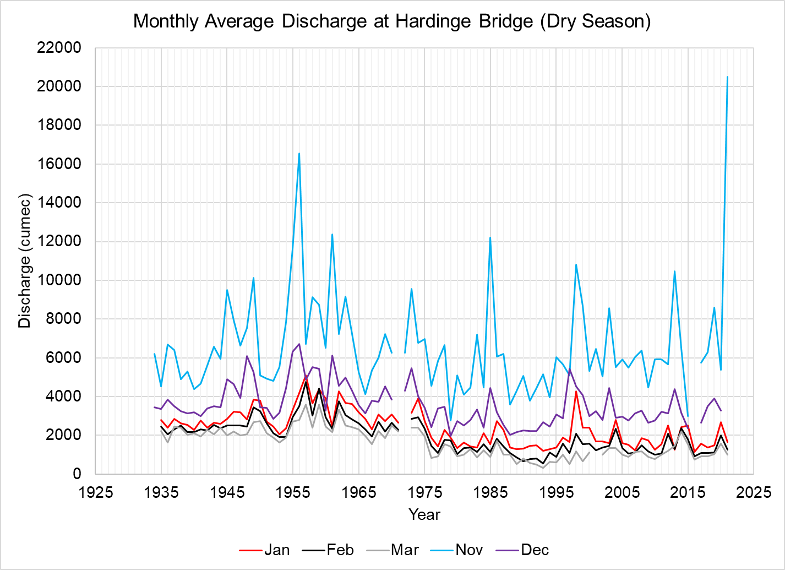

**Figure 4.1** Monthly average discharges of the Ganges River at Hardinge Bridge

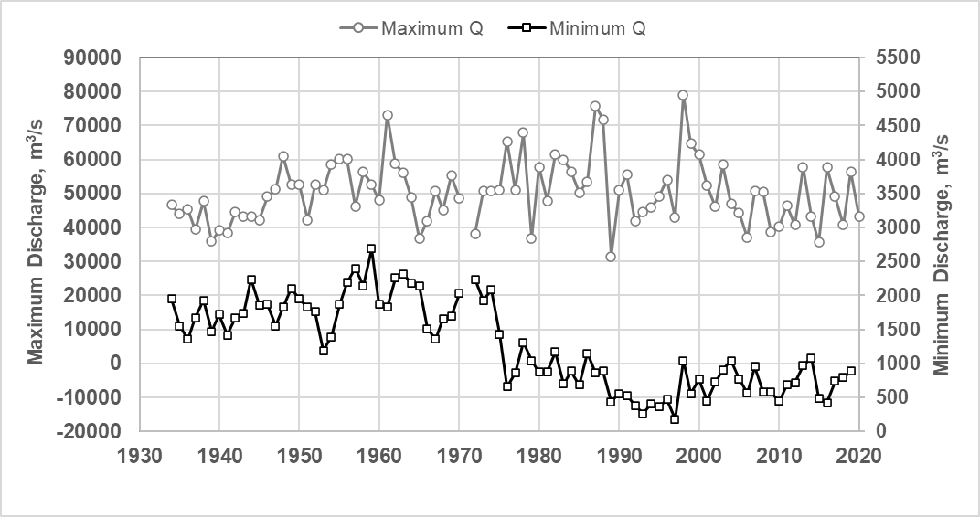

**Figure 4.2** Yearly Maximum and minimum discharges of the Ganges River at Hardinge Bridge

Consequently, dry season flow through the Gorai River also shows declination trend remarkably after 1980s. Monthly average historical discharge variation at Gorai Railway Bridge is presented in **Figure 4.3**.

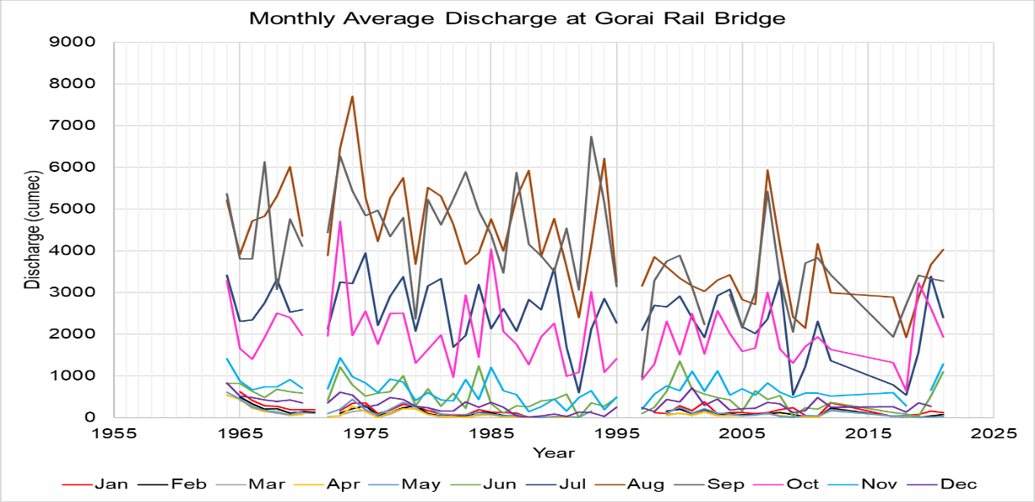

**Figure** **4.3** Monthly average discharge variation of the Gorai River at Gorai Railway Bridge

IWM also carried out field survey to collect bathymetry, planform, discharge, water level, sediment concentration, salinity etc. data for the study area as applicable to use and furnish the assigned study. Detail information on the surveyed data has been incorporated in the **Interim Report**. The study area focusses the Ganges-Gorai River and its downstream that includes Madhumati, Kaliganga, Kocha, Rupsha, Atai, Baleswar, Pussur, Sibsa, Aura Sibsa, Dhaki etc. Maximum discharge measured on 16th August 2021 at the Ganges and Gorai River shows 46,559 m3/s and 4,203 m3/s respectively. The maximum observed flow diversion towards Gorai River for 2021 was found about 13.42% at the end of July. Besides this, minimum flow diversion of about 1.15% was observed in two consecutive months, i.e., for the month of March and April 2021. Flow diversion scenario towards Gorai from Ganges River (up to February 2022) has been assessed from IWM’s collected data of 2021-2022, which is presented in **Figure 4.4**.

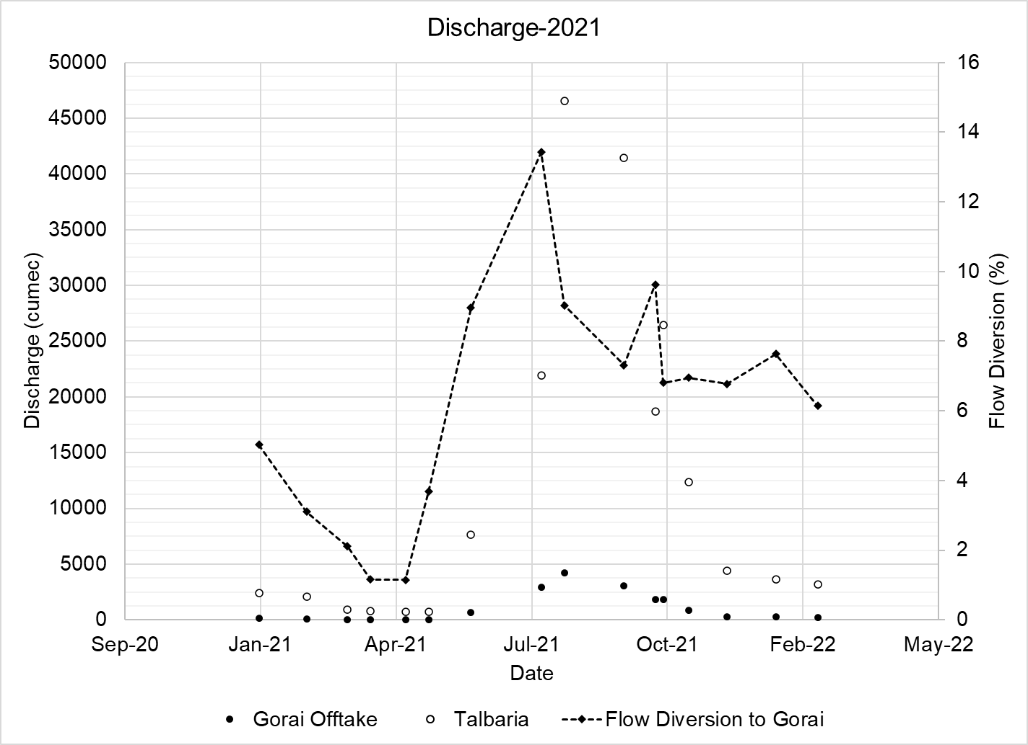

Discharge 2021-2022

**Figure 4.4** Flow diversion to the Gorai for 2021-2022

### 4.2 Water Level

Historical water level data (**Figure 4.5** and **Figure 4.6**) have been collected from BWDB for the Ganges and Gorai at Hardinge Bridge and Gorai Railway Bridge stations respectively. Maximum water level at Harding bridge was observed 15.19 m PWD in 1998 and minimum water level was found 4.22 mPWD in 1993. At Talbaria it is observed 14.53 and 3.56 mPWD for the same year. The average and minimum water level indicates a declining trend during post-Farakka period.

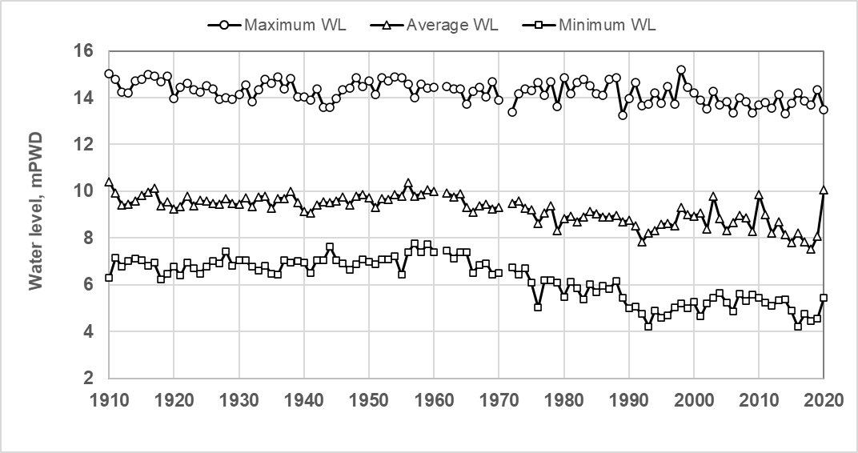

**Figure 4.5** Maximum, minimum and average Water Level of the Ganges at Hardinge Bridge

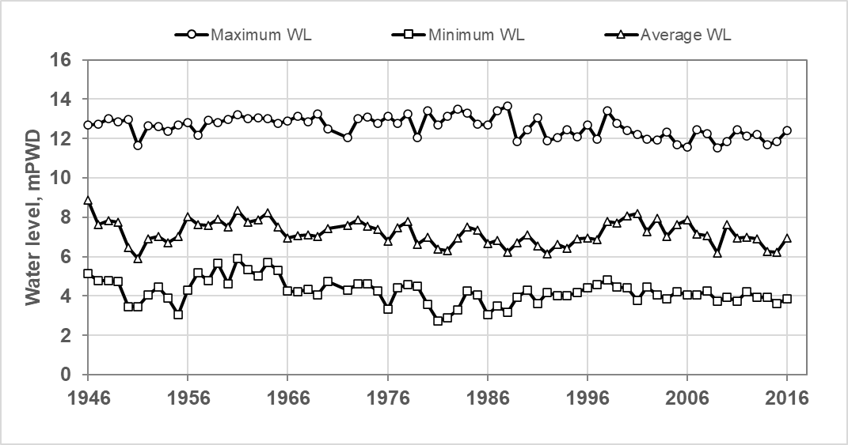

**Figure 4.6** Maximum, minimum, and average water level of Gorai River at Gorai Railway Bridge

For the present study, water levels measured BY IWM at several locations of the Gorai River have been recorded also. A typical plot, however is shown in **Figure 4.7**.

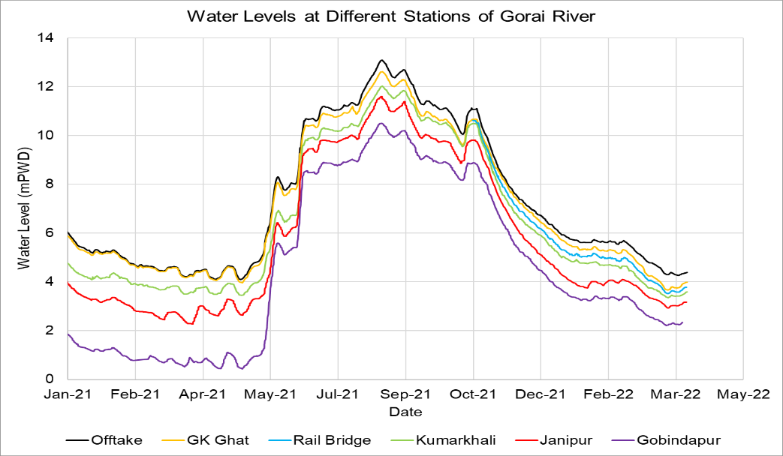

**Figure 4.7** Measured Water Levels at different locations of Gorai River

### 4.3 Planform analysis

Planform analysis for the Ganges and Gorai covering the period 1976-2022 has been done (**Figure. 4.8**) which shows that bank lines shifting of the Ganges right bank upstream of Gorai offtake is still present which may be regarded as one of the primary causes of accelerating the sedimentation processes at the offtake area. Changes of Offtake width with time is also shown in **Figure 4.9**.

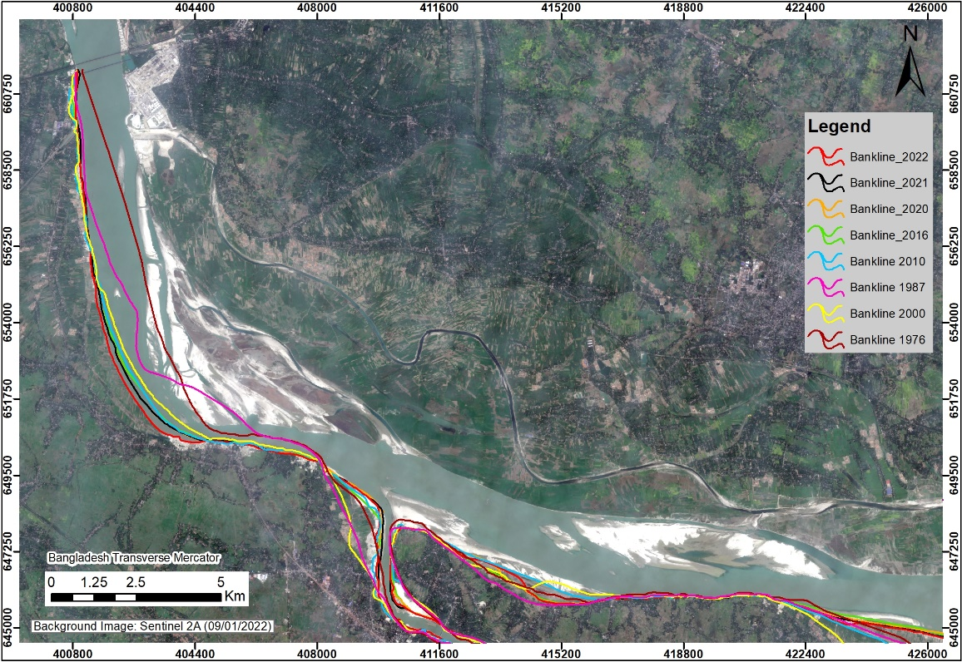

Vulnerable area

Talbaria

Kushtia Sadar

Hardinge Bridge

**Figure 4.8** Ganges right bank shifting upstream of Gorai offtake

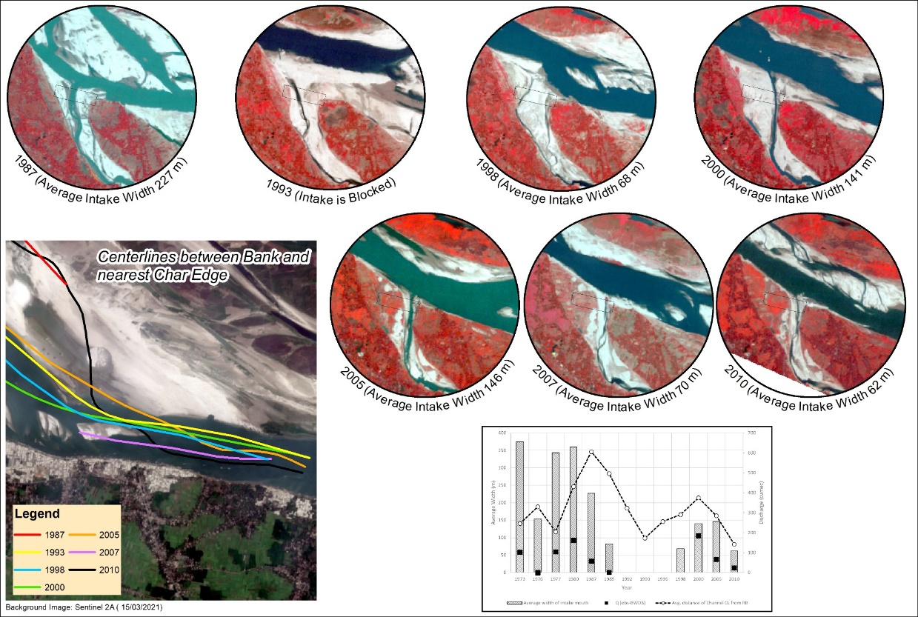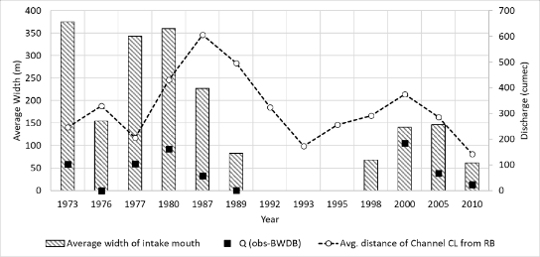

**Figure 4.9** An overview for the changes of Gorai Offtake width

Erosion-accretion pattern for the Ganges River within the study area is also estimated and presented in **Figure 4.10**. Satellite images analysis reflect that the rate of erosion is higher for the duration of 1976-2005 and after that it reduces compared to the accretion rate. Char accretion rate, shown in **Figure 4.11** indicates the silting up of the Ganges bed level and development of multiple sand bars at left bank of Ganges River near Talbaria resulting in shifting of main channel towards right bank.

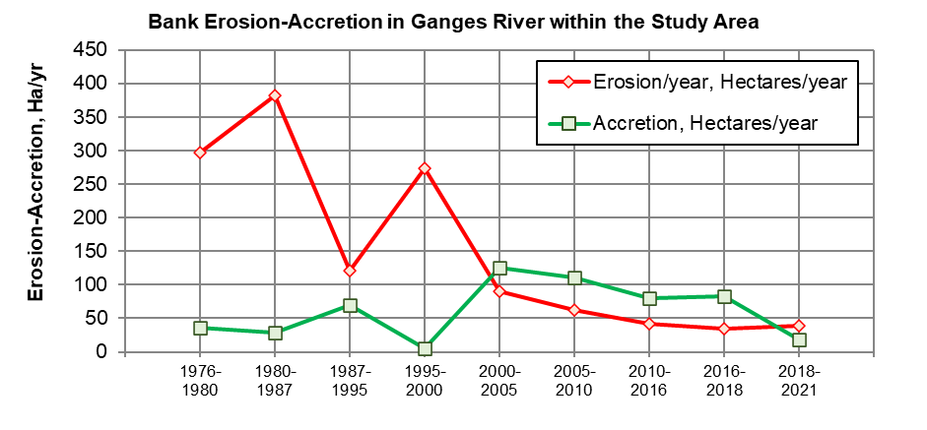

**Figure 4.10** Bank erosion accretion in the Ganges River within the study area

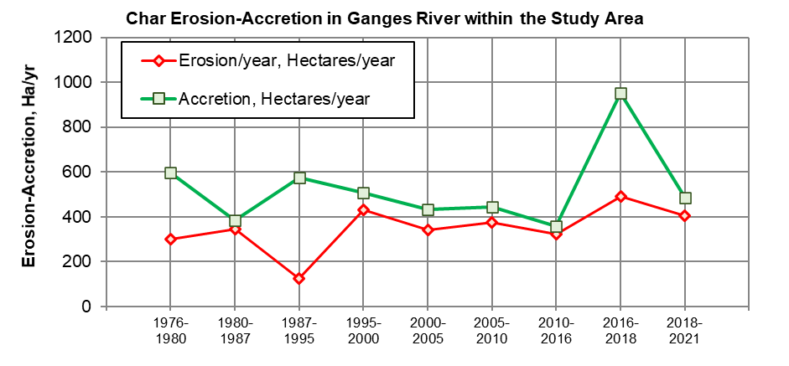

**Figure 4.11** Char erosion- accretion in the Ganges within study area.

### 4.2.5 Sediment transport

Suspended sediment concentrations measured at four locations within the Ganges-Gorai study area and available historical data have been analyzed and presented in **Figure 4.12** to **Figure 4.14**. Sediment concentrations and developed rating curves exhibits high sediment flow concentrations and transport rates during the monsoon, both in the Ganges as well as in the Gorai. Huge Sediment transport can be observed to flow through the Ganges and in the Gorai.

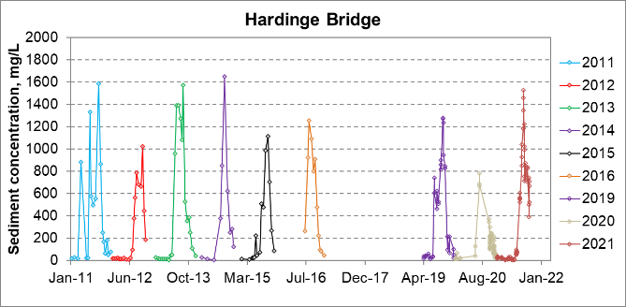

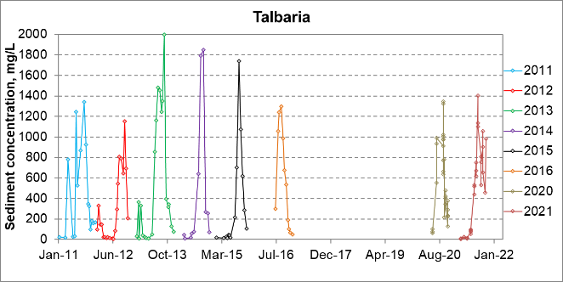

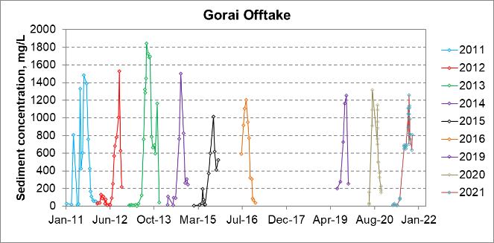

**Figure 4.12** Measured suspended sediment concentrations at different locations within the study area

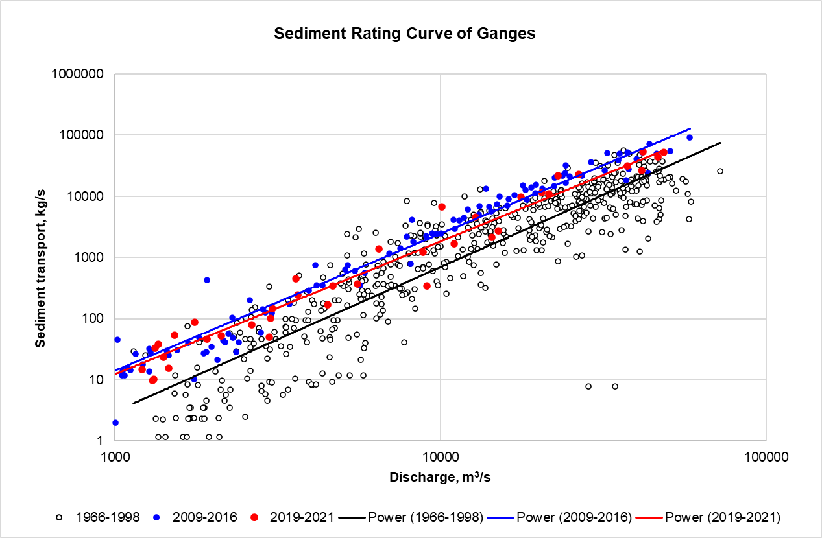

**Figure 4.13** Sediment rating curves of the Ganges River at Hardinge Bridge

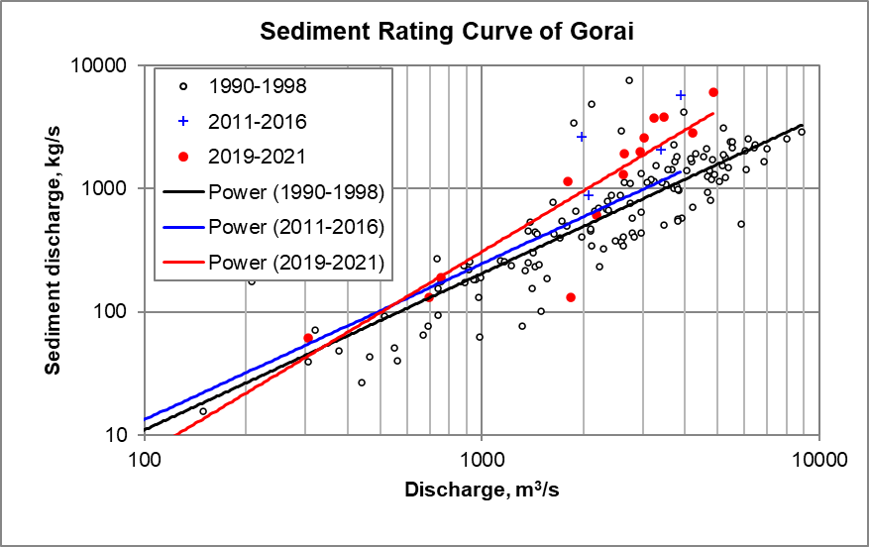

**Figure 4.14** Sediment rating curves of the Gorai at Gorai Rail Bridge

# MODEL SETUP, DEVELOPMENT AND CALIBRATION CONSIDERATIONS

Five different models are being used to meet the objectives of the ongoing main study. These are the South West Regional Model (SWRM), Bay of Bengal Model (BoBM), Ganges Gorai River System Model (GGRSM), Pussur- Sibsha-Baleswar River Model (PSBRM) and 1D salinity Model. Brief conceptual description of these models has been provided in the **Interim Report.** For this technical report, outputs has been extracted mainly from the GGRSM.

## 2D Morphological Model of GGRS

The existing 2D morphological model of Ganges Gorai River system has been updated with recent data. This model includes about 50 km of the Ganges River and 30 km of the Gorai River as stated earlier in Chapter-2. Updated bathymetry data of 2021 has been super imposed on the newly modified curvilinear grid and new interpolated bathymetry has been generated and used as initial/base condition for model simulation.

## Model Calibration and Validation

Calibration and validation of 2D morphological model for Talbaria bank protection works along with model input parameters have been optimized minimizing the differences between observed and simulated data/results (sample plot in **Figure 5.1**). Using depth dependent values of Chezy, the following points were selected for calibration.

* Discharge and water levels at selected points
* Velocity at selected points
* Sediment transport at HB and Gorai Railway Bridge.
* Cross sections at selected sections of the Ganges, Gorai Offtake and Gorai.

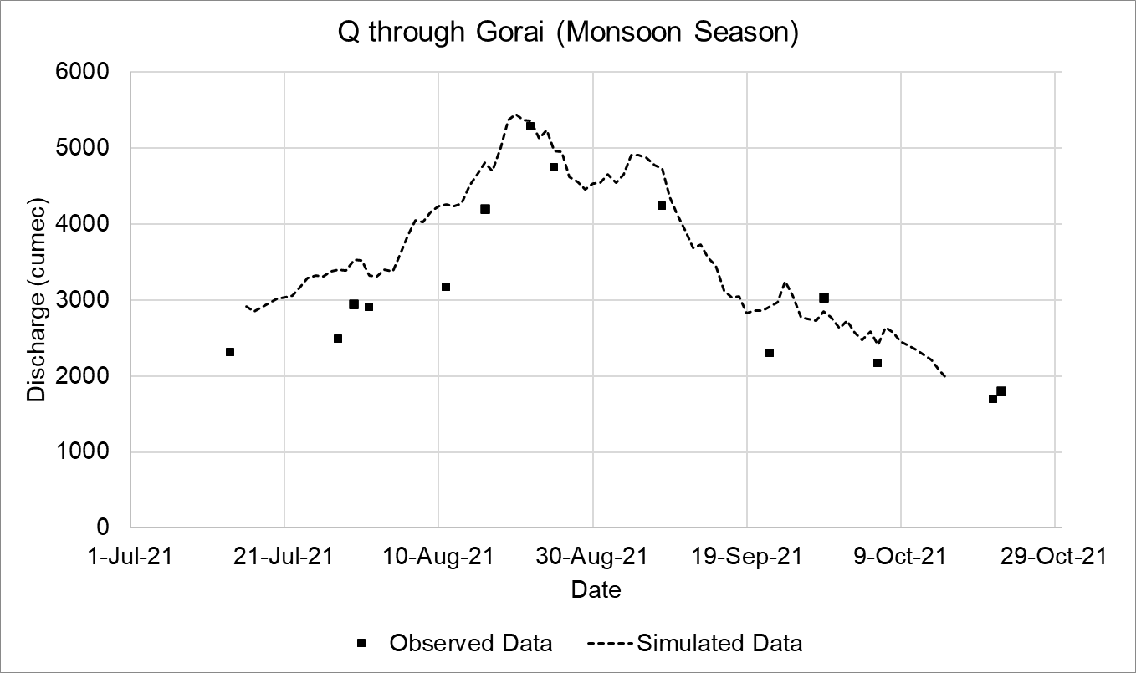

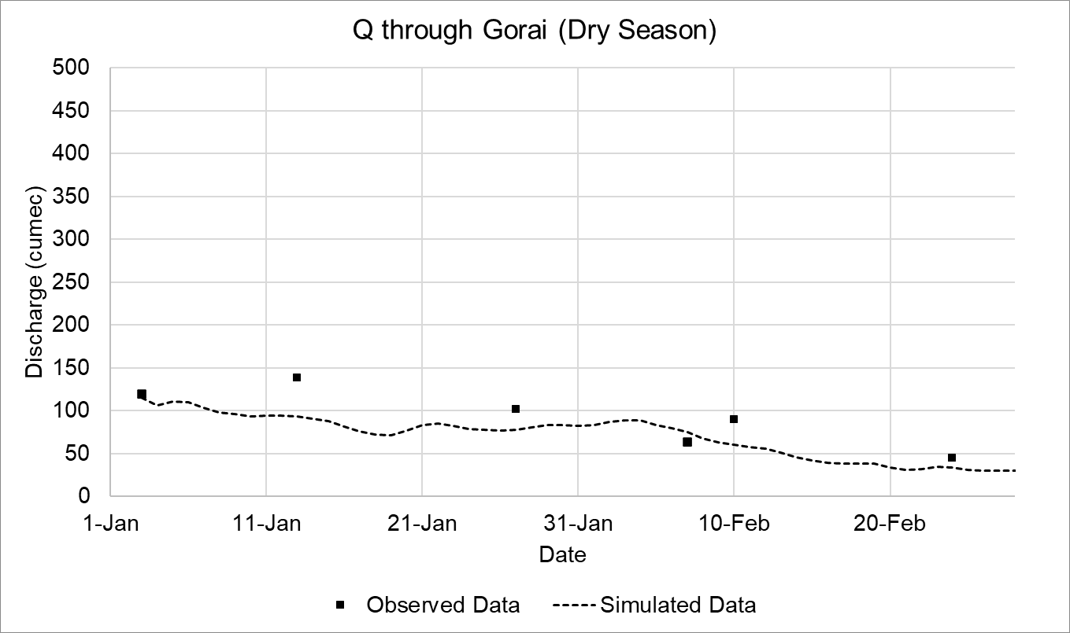

**Figure 5.1** Calibration of Discharge through Gorai Offtake.

# EVALUATION OF THE SIMULATED OPTIONS

Considering both the Talbaria erosion protection and the probable reasons for declining of Gorai dry season flow as studied in different times along with a view to formulate a sustainable management system of Gorai River Basin, various engineering interventions have been simulated (**Table 6.1**, **Figure 6.1**) and their effectiveness have been evaluated to achieve an acceptable Gorai River Basin management plan. Since there is severe bank erosion at Talbaria, accordingly the Ganges right bank erosion protection is a matter of serious concern. Moreover, passing the monsoon of 2021, right bank erosion at Talbaria has been increasing recently and causing sufferings to the people living at that area. Emergency permanent bank protection works are therefore necessary for the immediate protection of Talbaria erosion prone area. Considering the concept of bank protection at Talbaria while keeping in mind the long-term improvement of the Gorai offtake condition, a series of groynes and bank revetment have been found most effective.

Table 6.1 Simulated Options

| **Options** | **Planform and bathymetry** | **Interventions** | **Hydrological**  **conditions** | **Objectives** |
| --- | --- | --- | --- | --- |
| Base condition | Ganges-Gorai planform and bathymetry (November-2021) | Present existing conditions | Discharges of average year flood event July-November | Set up base condition to compare with options simulations |
| Option-1 | Do | Existing conditions+ Groyne at R/B of the Ganges,1600m u/s of Gorai offtake | Do | Natural channel creation throughout the year at the offtake. Increase dry season flow through Gorai, decrease salinity at selected downstream locations of SW region. |
| Option-2 | Existing conditions+ Groyne at R/B of Ganges at 500m u/s of offtake | Do | Natural channel creation throughout the year at the offtake. Increase dry season flow through Gorai, decrease salinity at selected downstream locations of SW region. |
| Option-3 | Existing conditions+ Groyne length 600m at R/B of Ganges at 900m u/s of Gorai offtake | Do | Natural channel creation throughout the year at the offtake. Increase dry season flow through Gorai, decrease salinity at selected downstream locations of SW region. |
| Option-4 | Existing conditions+ Groyne at R/B of Ganges at 2300m u/s of Gorai offtake | Do | natural channel creation throughout the year at the offtake. Increase dry season flow through Gorai, decrease salinity at selected downstream locations of SW region. |
| Option-5 | Existing conditions+ Groyne at R/B of Ganges at 1800m u/s of Gorai offtake | Do | Natural channel creation throughout the year at the offtake. Increase dry season flow through Gorai, decrease salinity at selected downstream locations of SW region. |
| Option-6 | Existing conditions + Submerged vanes at d/s of Gorai offtake (750m from offtake). Top elevation 10m pwd | Do | Sediment diversion towards Ganges and channel development at Ganges near Gorai Offtake and natural channel creation throughout the year at the offtake. Increase dry season flow through Gorai, decrease salinity at selected downstream locations of SW region. |
| Option-7 | Existing conditions + Submerged vanes at d/s of Gorai offtake (500m from the offtake. Top elevation 10m pwd | Do | Sediment diversion towards Ganges and channel development near Gorai Offtake. Increase dry season flow through Gorai, decrease salinity at selected downstream locations of SW region. |
| Option-8 | Existing conditions + revetment at Talbaria and Gorai Offtake(length) | Do | Offtake width optimization, average velocity increase at the offtake, create natural channel in the dry season. Increase dry season flow through Gorai, decrease salinity at selected downstream locations of SW region. |
| Option-9 | Existing conditions + Series of groynes at Talbaria, right bank of the Ganges, u/s of Offtake | Discharges of average year flood event July-November  and  December to March of average year flood | Ganges right bank stabilization and right bank channel alignment shifting, natural channel creation throughout the year at the offtake. Increase dry season flow through Gorai, |
| Option-10 | Existing conditions + Submerged vanes near Gorai offtake (600m u/s and d/s from offtake),Top elevation 8m PWD. | Discharges of average year flood event July-November | Sediment diversion towards Ganges and channel development near Gorai Offtake; natural channel creation throughout the year at the offtake. Increase dry season flow through Gorai, decrease salinity at selected downstream locations of SW region. |
| Option-A1-R | Existing conditions+ Gorai offtake right bank revetment+ Flow divider as option A1-R of DHV 2001 | Do | Offtake width optimization, more flow attraction to the Gorai, average velocity increase at the offtake, create natural channel at the offtake in the dry season and decrease salinity at selected downstream locations of SW region. |
| Option-11 | Existing conditions+ Bank revetment at right bank starting from GK intake canal to Mangalbaria groyne +Flow divider at Gorai Offtake. | Discharges of average year flood event July-November  December to March of average year flood  Discharges of 1 in 100 year flood event July-November | Ganges right bank protection and natural channel creation throughout the year at the offtake. Increase dry season flow through Gorai, |
| Option-12 | Option-11 interventions+ Ganges dredging | Discharges of average year flood event July-November | Ganges right bank protection and natural channel creation throughout the year at the offtake. Increase dry season flow through Gorai. Combined with investigation of the effectiveness of the Ganges dredging on the Gorai offtake improvement. |

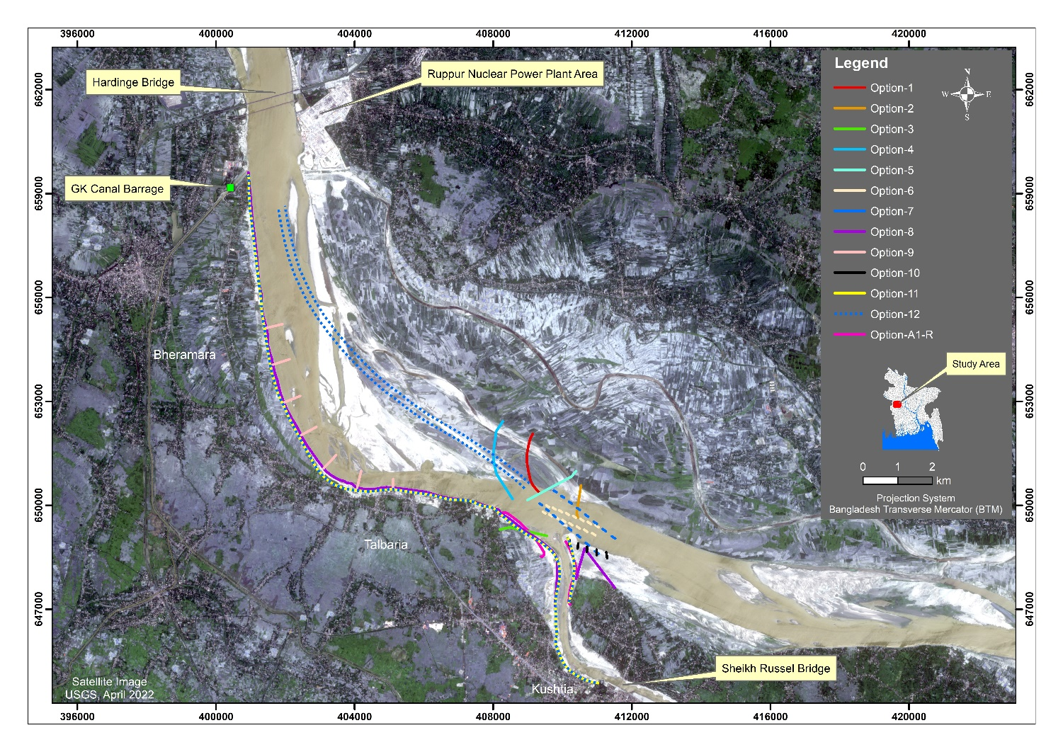

**Figure 6.1** Interventions simulated in the 2D morphological model.

## Description of Model Simulations of Talbaria Bank Protection Works

Different options have been simulated changing the intervention scenarios. Among all, series of groynes as well as continuous bank revetment (option-9 and option-11) both have been found to perform best in stabilization of the Ganges right bank at Talbaria. Mainly the following points were emphasized during the optimization process of bank protection measures:

* Selection of proper river bank protection measures for erosion mitigation, specially near Talbaria.
* Optimization of length, location, orientation, and number of groynes and requirements of bank revetments.
* Discharge condition and morphology at the Gorai offtake.
* Near bank velocity and minimum bed levels around the structures.
* Effectiveness of Ganges dredging
* Morphological changes at the Ganges right bank channel upto Gorai offtake etc.

### 6.1.1 Base condition

Base condition has been setup updating the existing 2D morphological model with all existing conditions and current bathymetry and topographic survey data without any proposed interventions. The surveyed and interpolated bathymetry for the base condition is shown in **Figure 6.2** and **Figure 6.3**,respectively.

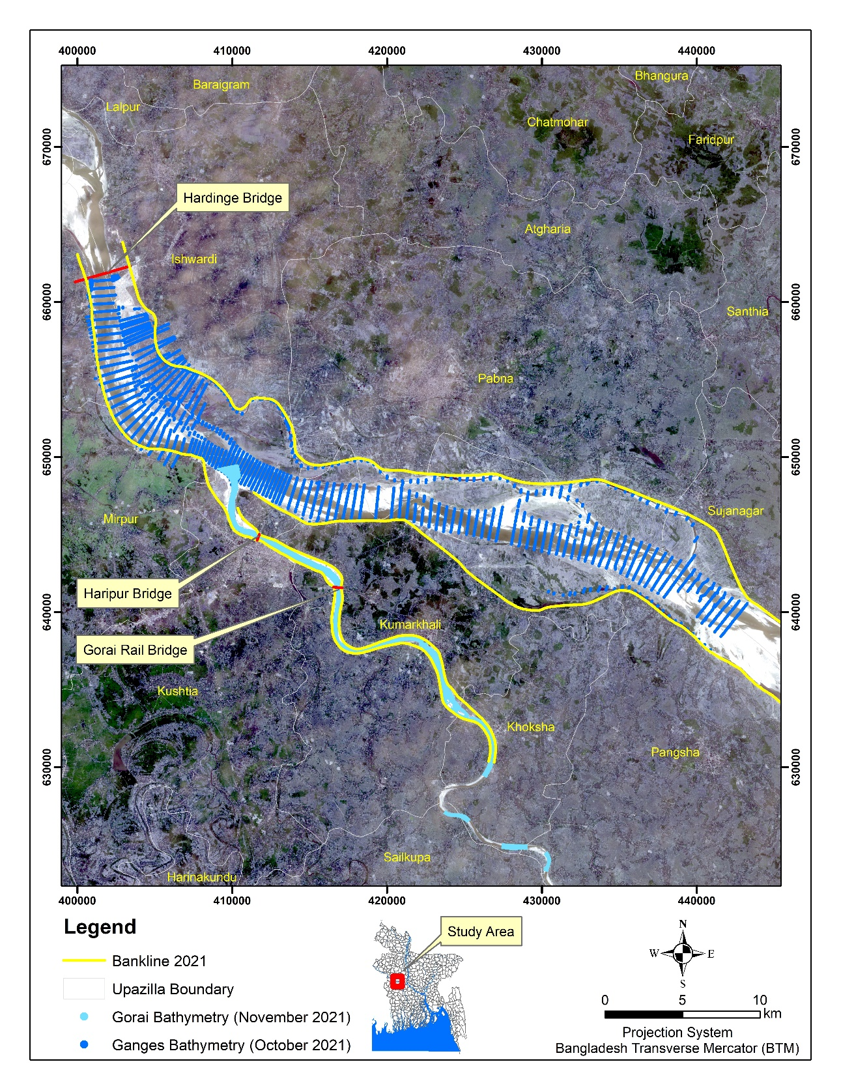

Sheikh Rasel Bridge

**Figure 6.2** Surveyed Data of the Ganges and the Gorai River for the year 2021

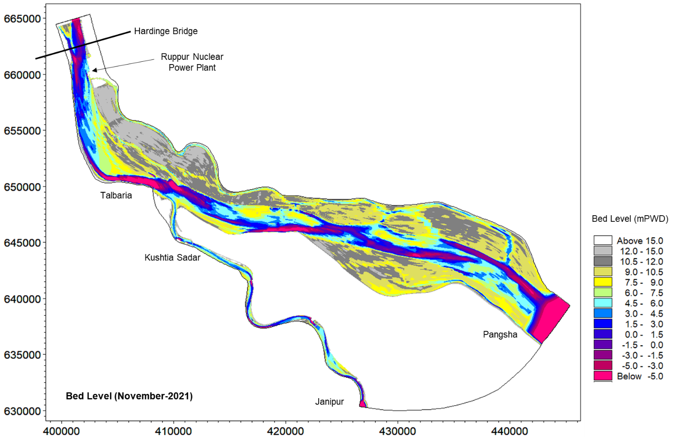

**Figure 6.3** Interpolated Bathymetry Developed for the 2D morphological model.

### 6.1.2 Effectiveness of a Series of Groynes (Option-9)

Several simulations with series of groynes at Talbaria were carried out changing the design such as length, location, orientation, spacing and numbers of the groynes to optimize the design. Probable bed level, channel development, erosion/deposition at the end of four (04) consecutive monsoon flood event hydrographs simulation (End of November) can be seen in plots from **Figure 6.5** to **Figure 6.13**. Ganges right bank channel found to be shifted towards the main channel (river) which improves the approach flow at the offtake as well as deepening of Gorai River cross section immediate downstream of Gorai offtake. After model simulation at the optimized stage in the dry season, the Gorai discharge is found to be in improved condition within the range of 45-113 m3/s as shown in **Table 6.2**. The dry season probable flow diversion during scenario has been also found on average about 8.65% of the Ganges flow through Gorai Offtake with the proposed groynes.

The simulation results for bed levels show sedimentation just downstream of proposed groynes indicating proper functioning of the proposed interventions. Besides that, probable velocity vectors (**Figure 6.11** and **Figure 6.12**) show that flow field is almost at safe distance from the Ganges right bank under the present planform and groynes in optimized conditions. No significant back eddy was found between the groynes. After simulation, the results of 2D plot and Cross section between the groynes also show deposition as can be seen in 2D plot and representative cross sections. Maximum velocity at the tip of groyne has been found about 4.05 m/s against the design discharge. A deep channel is developed along the tip of the groynes. Approach flow to the offtake is more improved than without groynes conditions in terms of less sedimentation and increased dry season discharge into the Gorai.

Typical cross section plot comparison and bathymetry 2D plot shows the extent of deposition near the bank and shifting of thalweg towards the main channel of river that indicates the morphological improvement due to the proposed groynes compared with the base condition. Probable minimum bed level has been found about -35 mPWD near the groyne tip. Probable sediment flow through Gorai Offtake also decreases with the proposed groynes as shown in **Figure 6.13**.

It would be worthwhile to mention here that the simulation results are based on the combined hydrodynamic performance of all the groynes acting together. Whereas, in reality, all the groynes might not be possible to construct within one hydrological year. In that case the situation may be different, in particular at the offtake in terms of hydro morphology. Under these circumstances, it would be wise to monitor the situation in field and take action as required. After completing the construction of all the groynes, the performance of the proposed intervention is expected to work well as predicted from the model findings.

Considering the complexity of hydro-morphology of the study area and since the Ganges-Gorai are very active rivers, it would be essential to monitoring the field performances for a couple of years after construction of the groynes. Related data/information will also be required to collect in a systematic way to take any measures in the field in case of any adverse situation.

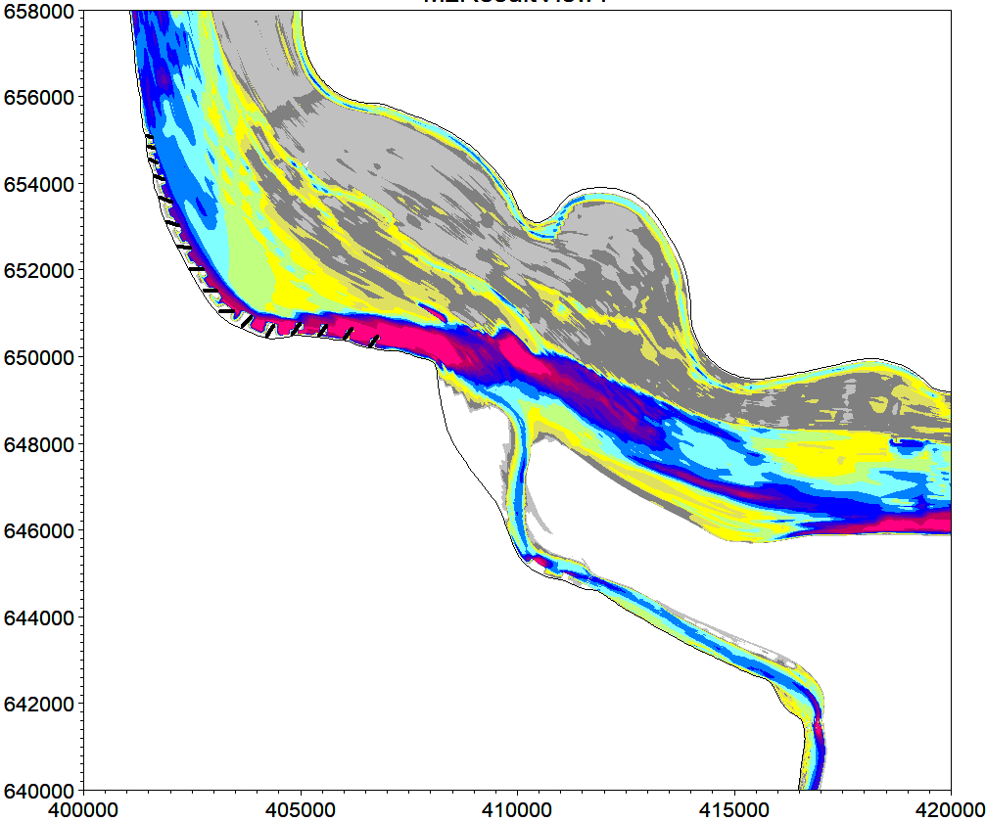

Talbaria

Kushtia Sadar

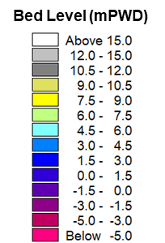

**Figure-6.4** Initial condition bathymetry plot with proposed groynes

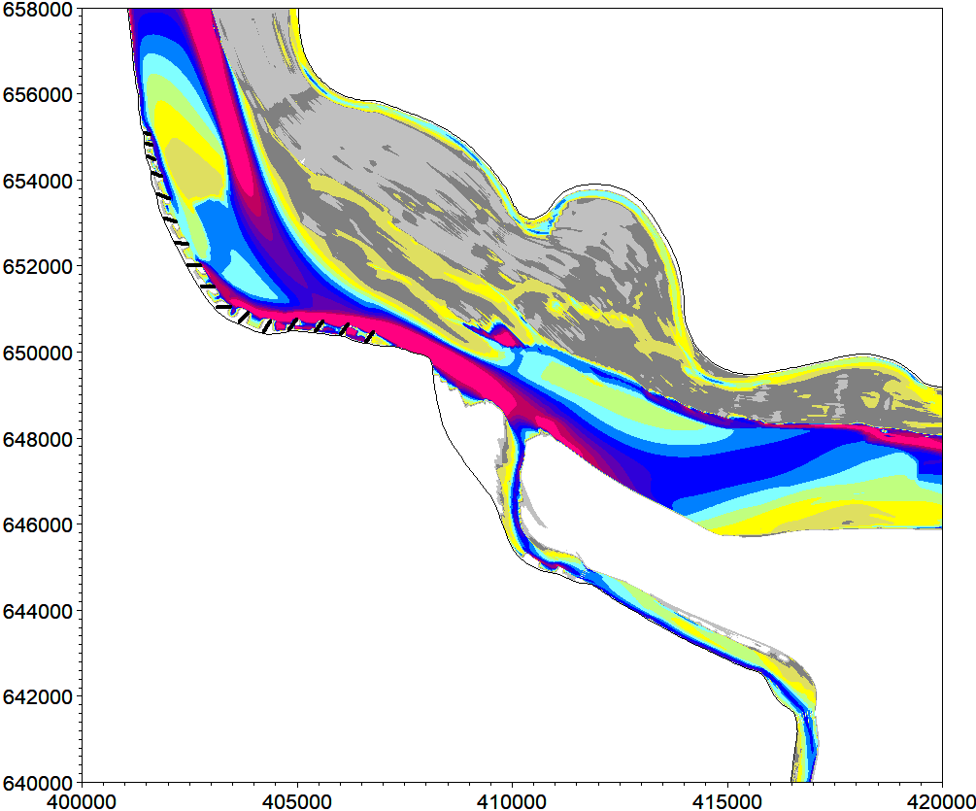

Talbaria

Kushtia Sadar



**Figure 6.5** Morphological development at Talbaria after fourth monsoon (End of November)

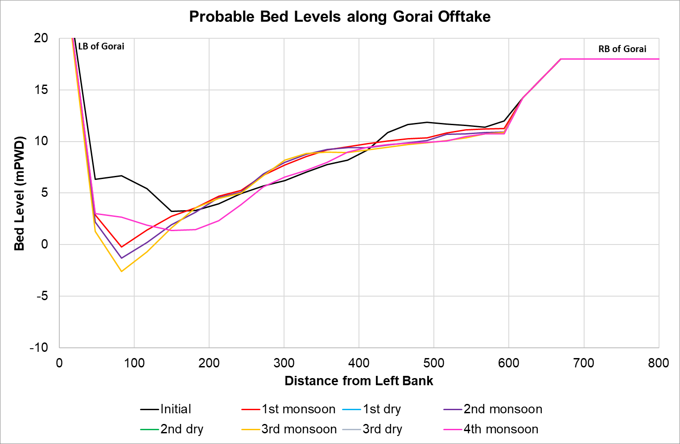

**Figure 6.6** Cross sectional change (Typical) at Gorai offtake due to the proposed series of groynes after fourth monsoon.

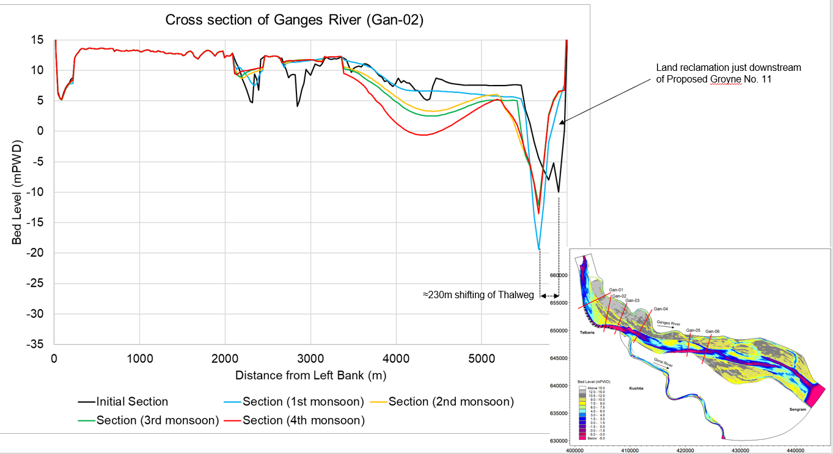

**Figure 6.7** Typical view of cross-sectional change between proposed Groynes 11-12

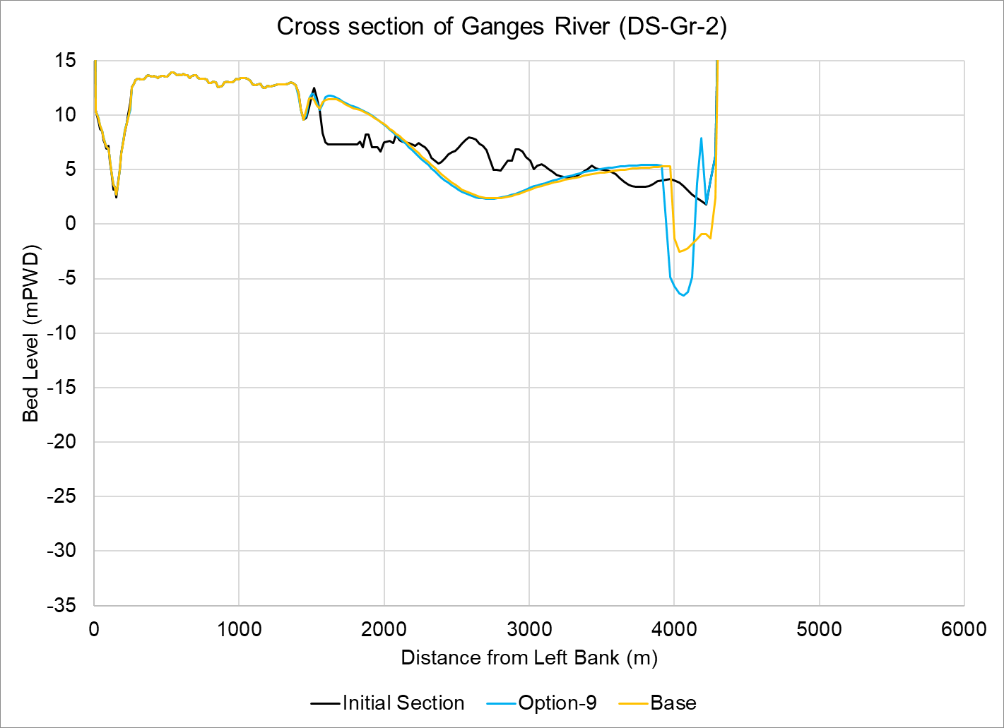

Sedimentation

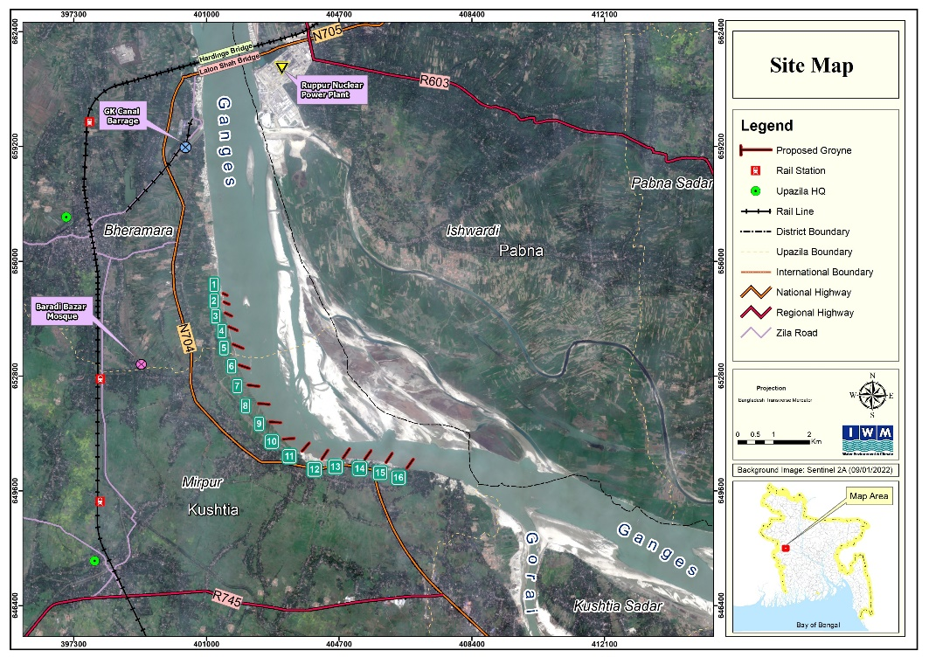

Shifting of thalweg towards main channel

**Figure 6.8** Cross section changes at downstream of groyne-2 at the end of simulation

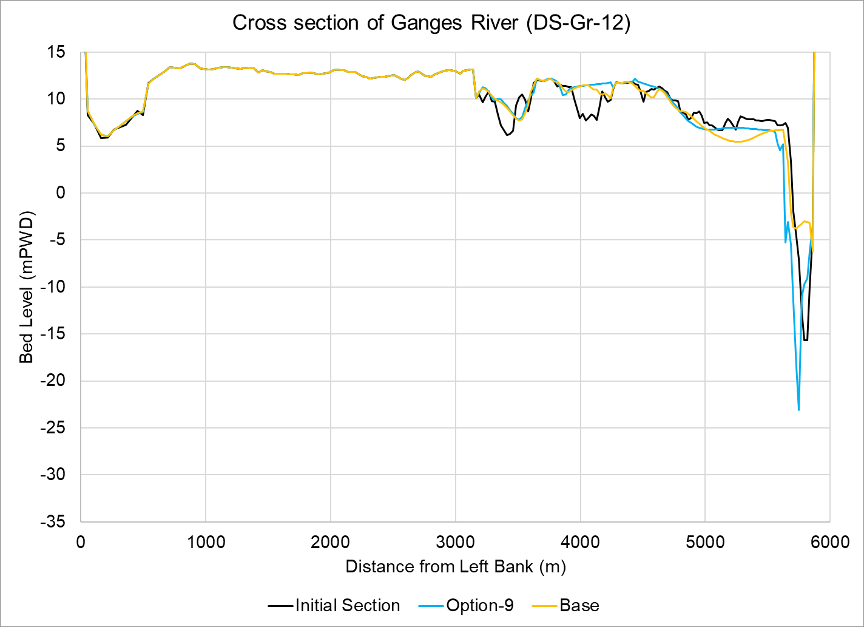

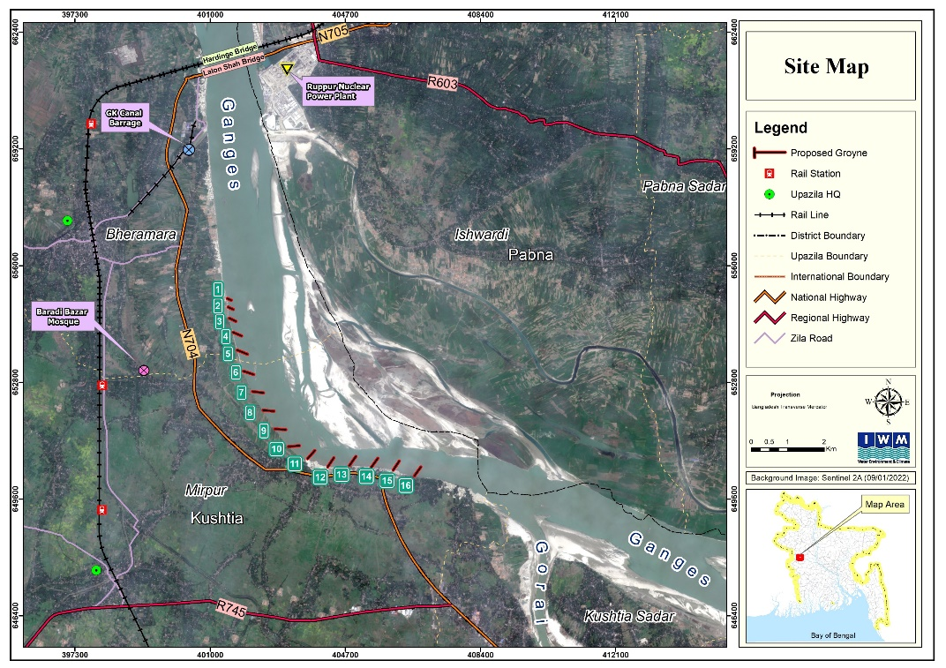

Shifting of thalweg towards main channel

**Figure 6.9** Cross section changes at downstream of groyne-12 at the end of simulation

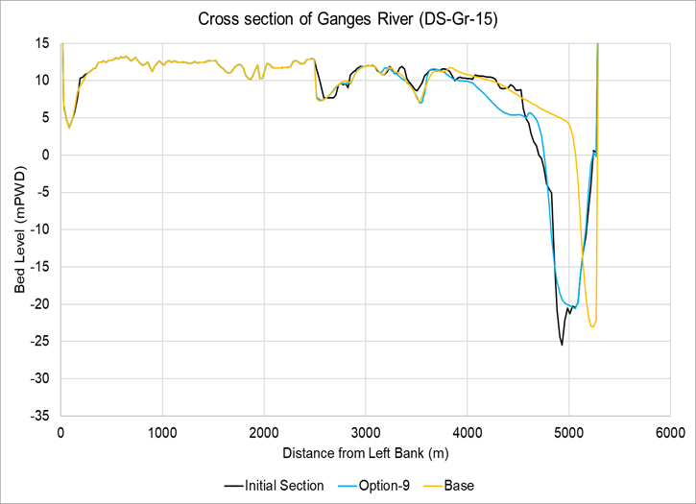



Sedimentation

**Figure 6.10** Cross section changes at downstream of groyne-15 at the end of simulation

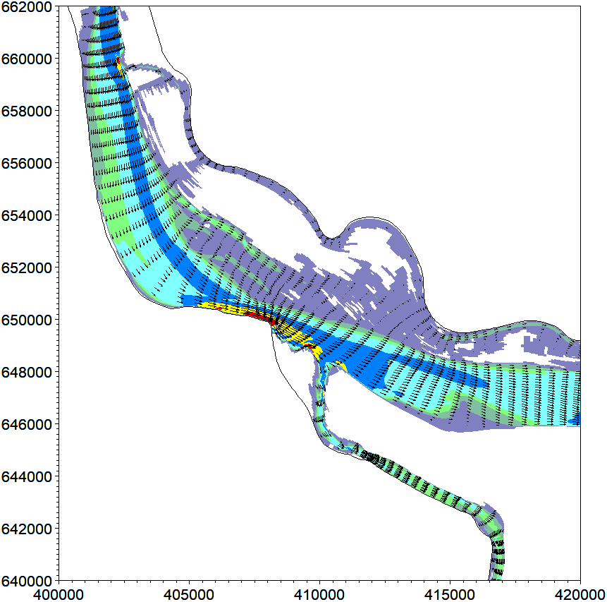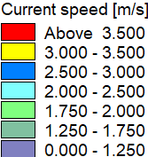

Talbaria

Kushtia Sadar

**Figure 6.11** Peak Flow Velocity vectors for base condition (1 in 100 year return period)

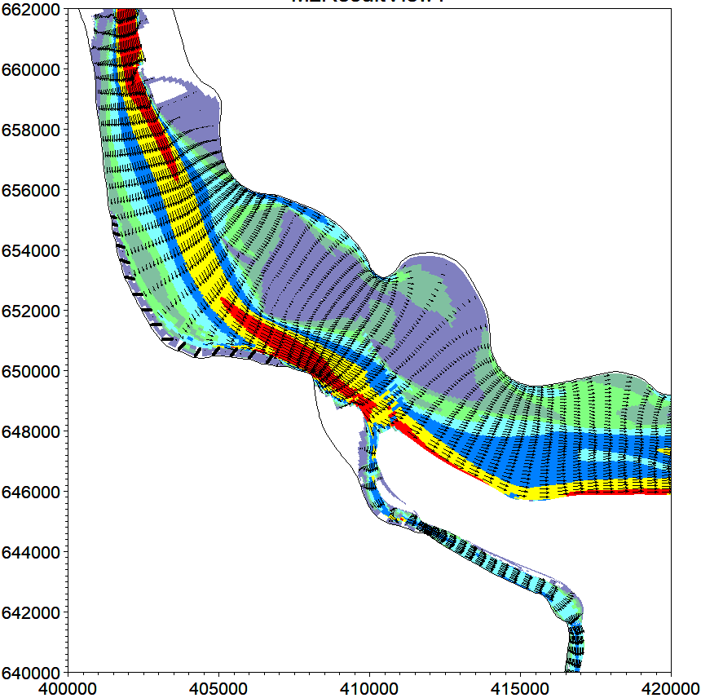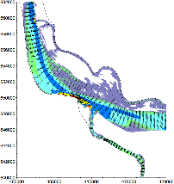

Talbaria

Kushtia Sadar

**Figure 6.12** Peak Flow Velocity vectors with proposed groynes (1 in 100 year return period)

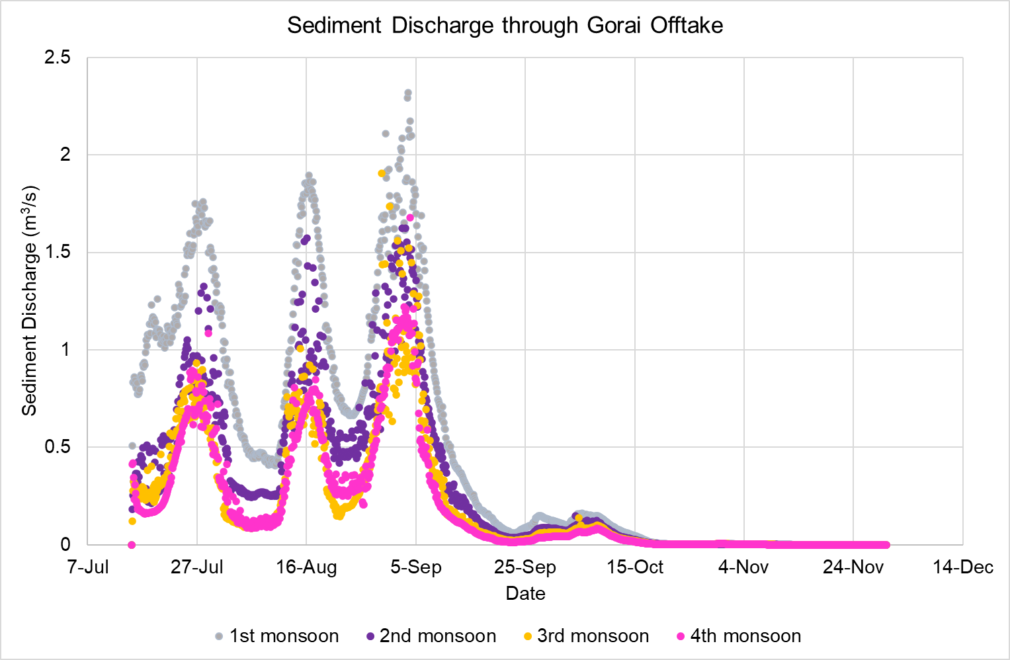

**Figure 6.13** Simulated sediment discharge through Gorai Offtake with proposed groynes

Table 6.2 Probable discharge scenarios through the Ganges and Gorai

|  |  |  |  |  |
| --- | --- | --- | --- | --- |
| **Time** | **Discharge at Gorai Offtake(m3/s)** | | **Discharge at Hardinge Bridge** | |
| **Monsoon**  **(2nd September)** | **Dry**  **(20th March)** | **Monsoon**  **(2nd September)** | **Dry (20th March)** |
| Base | 4545 | 0 | 42288 | 956 |
| 1st Year | 4683 | 45 |
| 2nd Year | 5060 | 90 |
| 3rd Year | 5021 | 113 |
| 4th Year | 4900 | - |

Table 6.3 Probable Discharge diversion through the Gorai

|  |  |  |  |
| --- | --- | --- | --- |
| **Time** | **Flow diversion through Gorai Offtake(%)** | | |
| **Monsoon(2nd September)** | **Dry(20th March)** | **Probable average in 20th March ( 3yrs simulation)** |
| Base | 10.75 | 0.00 | 8.65 |
| 1st Year | 11.07 | 4.71 |
| 2nd Year | 11.97 | 9.41 |
| 3rd Year | 11.87 | 11.82 |
| 4th Year | 11.59 | - |

### 6.1.3 Effectiveness of Bank Revetment and Flow Divider (Option-11)

Alternative to series of groynes, bank protection works with continuous bank revetment (about 20.83 km from GK intake canal to Mangalbaria Groyne) for Talbaria have been simulated in Option-11. Flow divider (about 1900m) at the left bank of the Gorai Offtake has been also considered in this simulation as mentioned in **Table 6.1**. The length, location and alignment of the proposed revetment and flow divider is shown in **Figure 6.14** and the interpolated bathymetry is shown in **Figure 6.15**. Besides, revetment design has been optimized from this simulation passing 1 in 100 year flood event. Offtake structure has also been optimized and found to work better in terms of discharges diversion through the Gorai and reduction of offtake siltation trend. Dry season discharge was found to vary 29-139 m3/s and flow diversion about 7.67% as shown in **Table 6.4** and **Table 6.5**.

As for the Talbaria protection, probable bed level and cross-section plots after passing one monsoon of average flood event are shown in **Figure 6.16** and **Figure 6.17**, respectively which clearly shows protection of right bank of Ganges near Talbaria. However, it is worthwhile to mention here that as revetment generally attracts the flow of a river, the thalweg of Ganges remains near the right bank, just a few meters away from the launching apron of the proposed revetment.

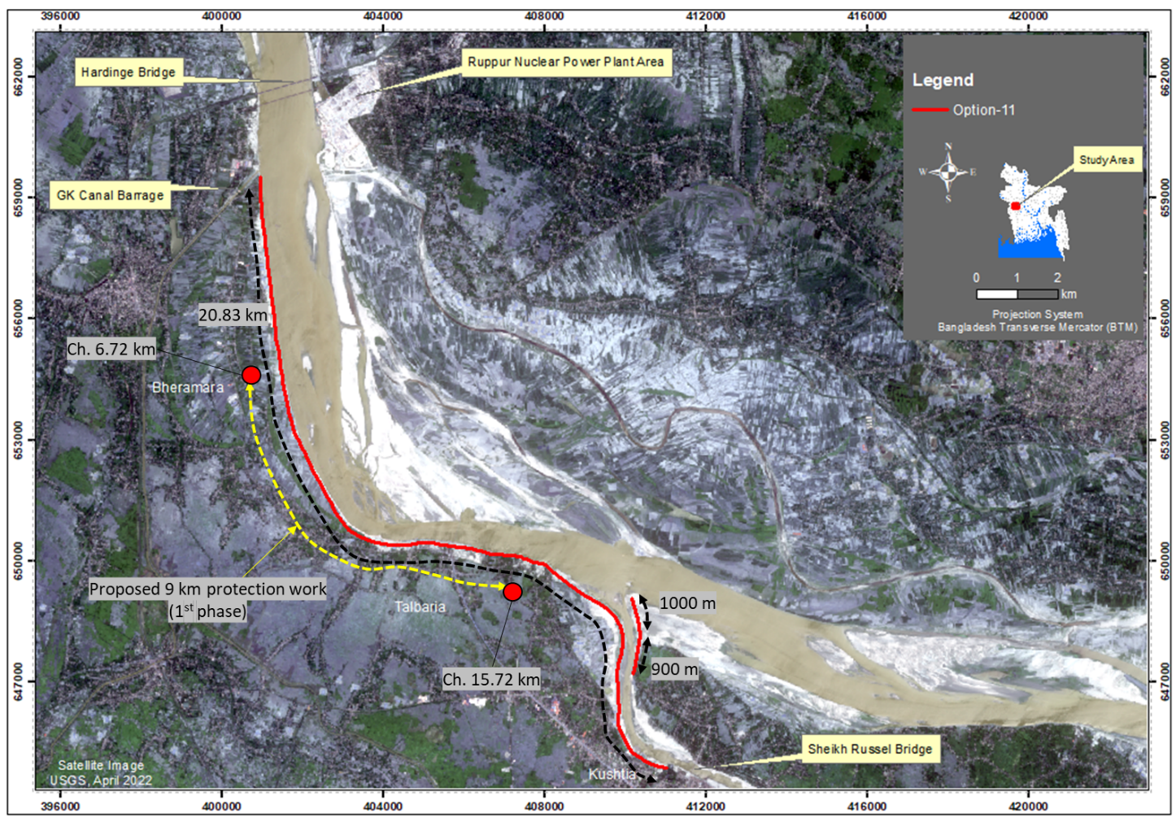

**Figure 6.14** Option-11 superimposed over satellite image of April-2022

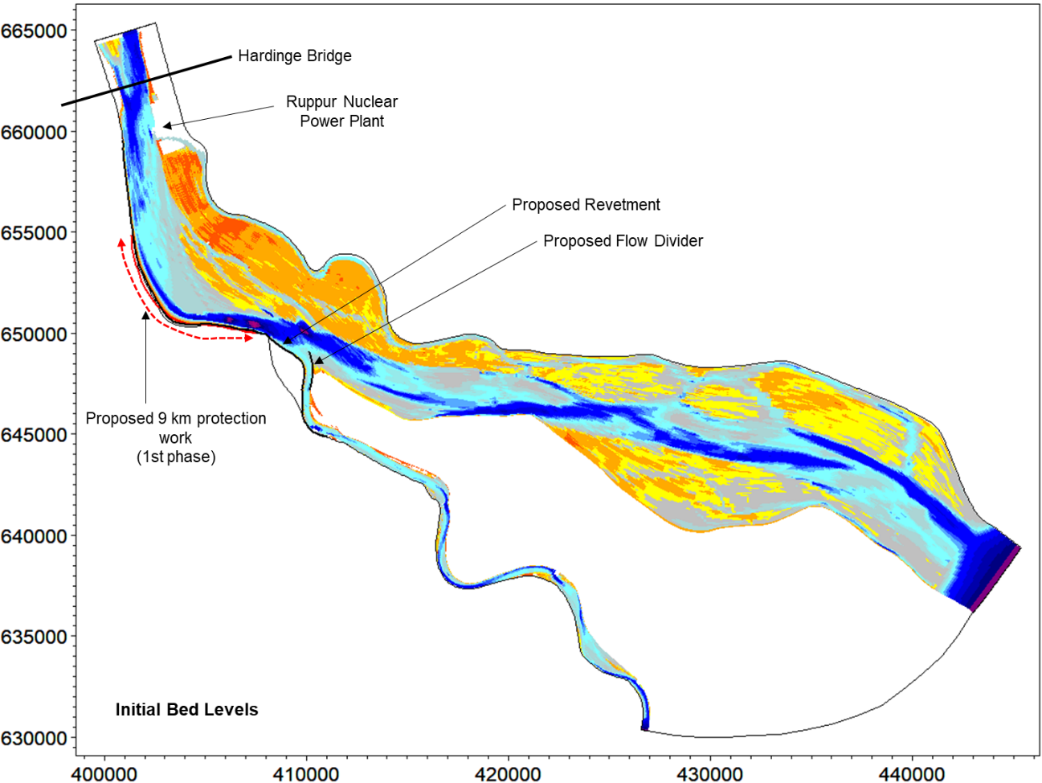

**Figure 6.15** Option-11 superimposed on initial bathymetry of November-2021

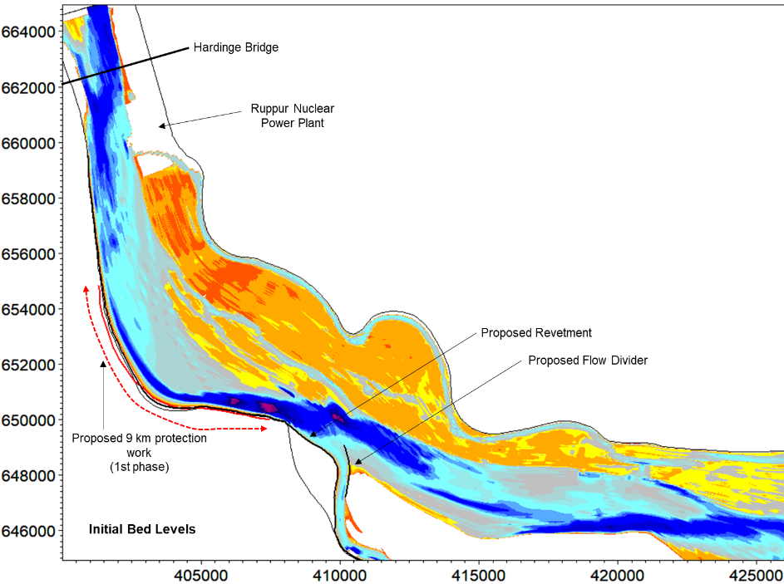

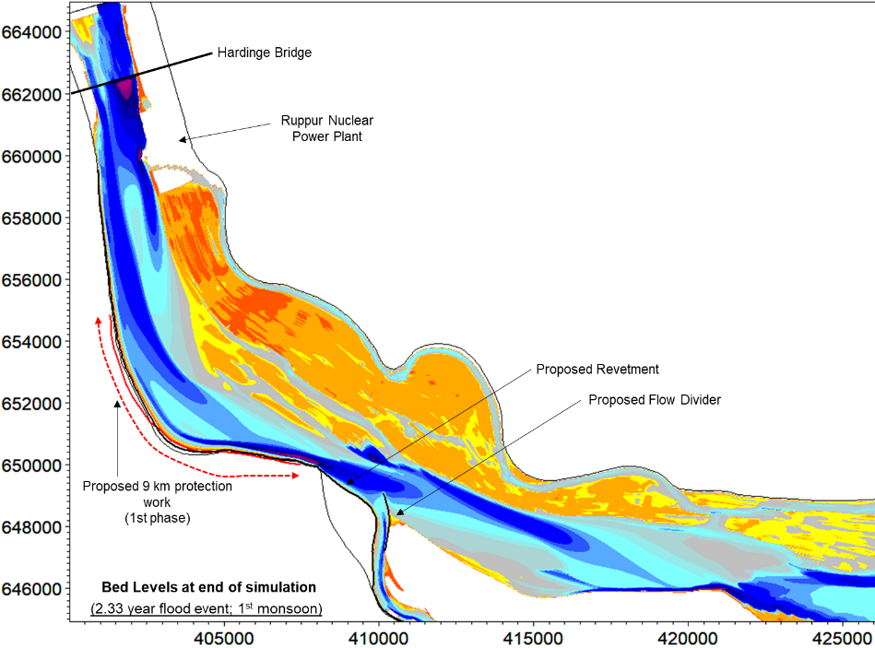

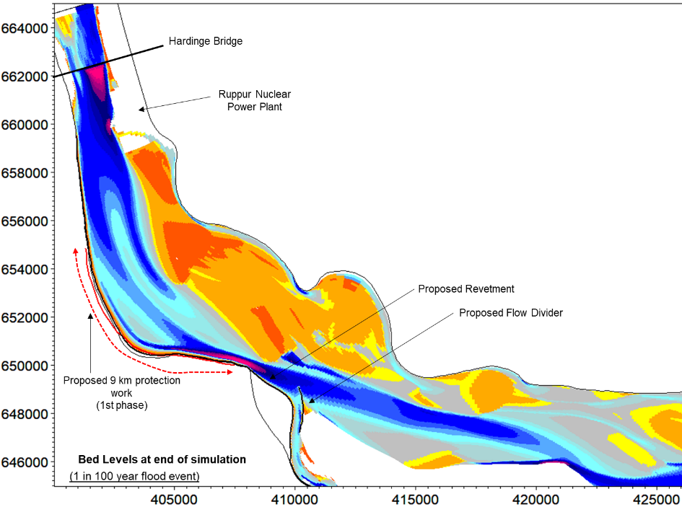

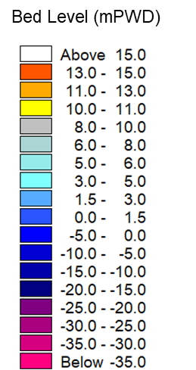

**Figure 6.16** 2D plot of morphological development at the study area with Talbaria revetment and Gorai Offtake flow divider (option-11)

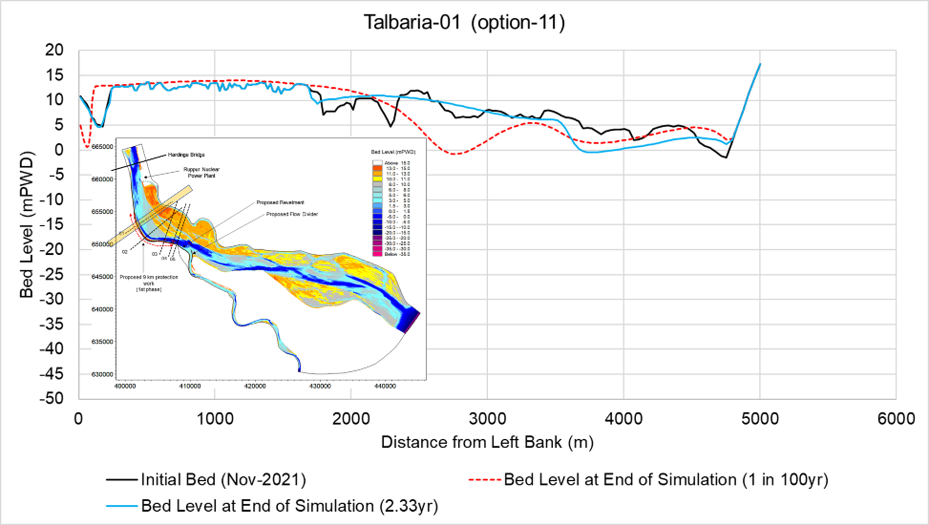

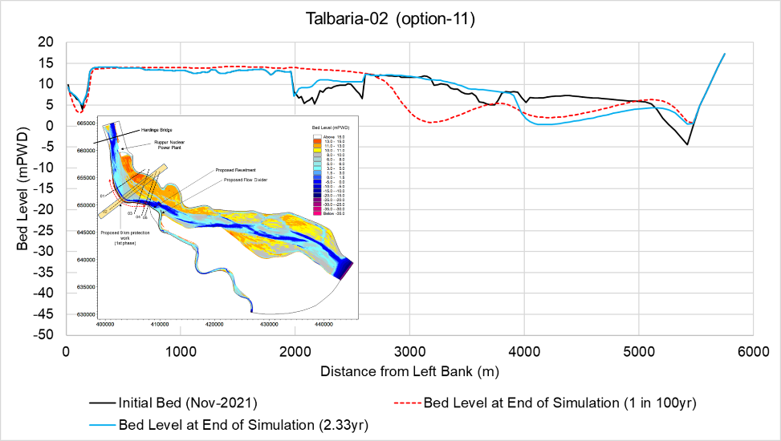

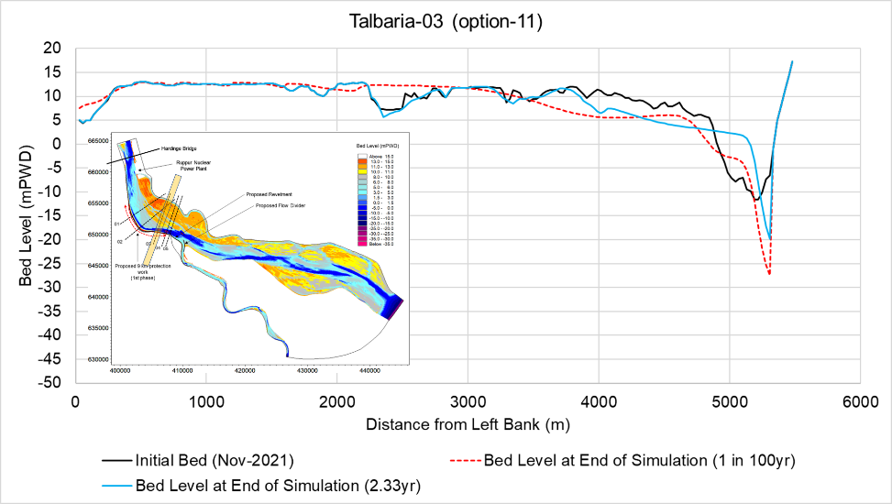

**Figure 6.17** Probable Cross-section of Ganges River with Talbaria revetment and Gorai Offtake flow divider (option-11)

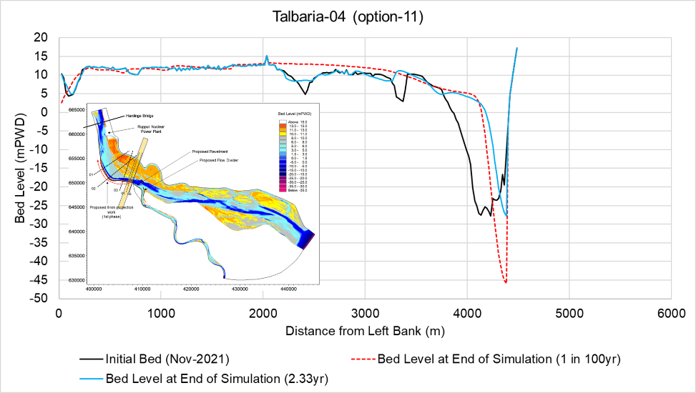

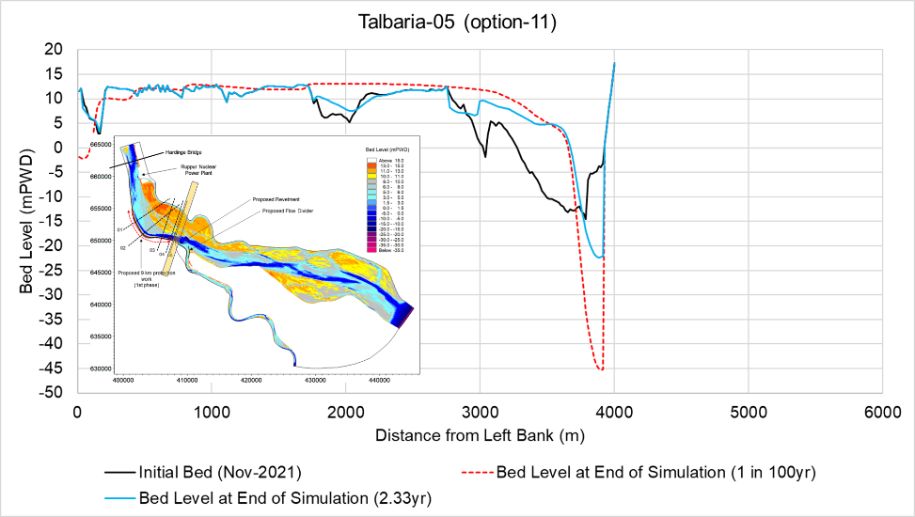

**Figure 6.17 (contd.)** Probable Cross-section of Ganges River with Talbaria revetment and Gorai Offtake flow divider (option-11)

**Long-Term Morphological Development at the Gorai Offtake**

The 2D morphological model of Ganges and Gorai River was simulated for the discharges (four consecutive monsoon hydrographs along with three consecutive dry seasons) at Hardinge Bridge with the proposed interventions as mentioned in **Table 6.1**. It is found form the model results that a defined channel is developed along the revetment which will ensure a dry season channel along the right bank of the Ganges (**Figure 6.18**). Proposed length and alignment of the revetment is expected to protect well the Talbaria erosion prone area and to stabilize further downstream riverbank upto Mangalbaria groyne. A dry season channel is also found to develop at the Gorai Offtake along the flow divider. This channel would help to develop a sustainable connection of the Gorai with the Ganges with proposed intervention in dry period. Besides, simulated sediment transport passing through the Gorai Offtake for four consecutive average flood events are predicted and ploted in **Figure 6.19**. In general, a decreasing trend of sediment discharge through the Gorai also supports the option -11 as one of the promising options. However, to achieve this situation in the field dredging at required level is to be carried out initially before full implementation of the proposed interventions are done.

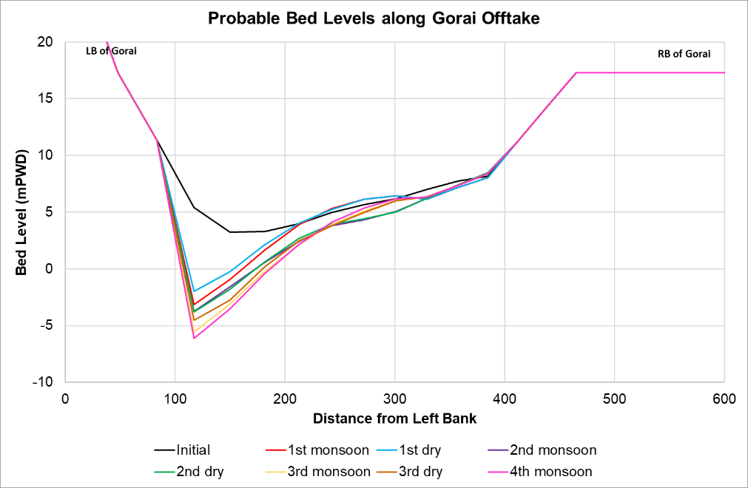

**Figure 6.18** Cross Sectional change after simulation at the Gorai Offtake in option-11

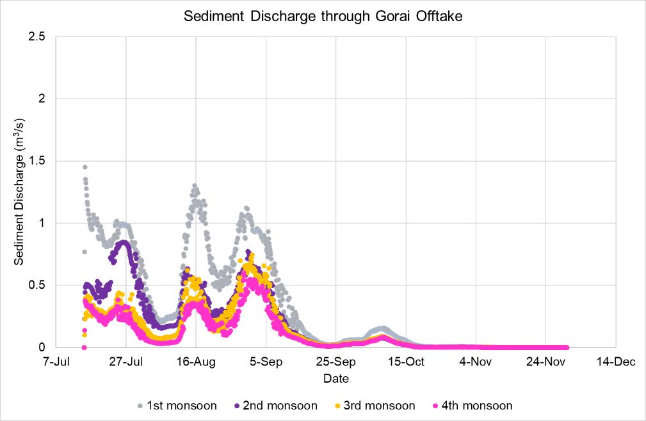

**Figure 6.19** Sediment discharge through the Gorai for option-11

*Discharge Through the Gorai*

Representative discharge through the Gorai in the dry as well as monsoon season is shown in **Table 6.4**. In particular, the probable dry season discharge is found to improve well with the proposed intervention. On average the dry season discharge is found about 29-139 m3/s based on simulated data of the 20th March. Dry season flow was found to divert through Gorai about 3-15% of the Ganges flow. Monsoon flow was also increased upto 11.50 %.

Table 6.4 Discharge condition during simulation in option-11

|  |  |  |  |  |
| --- | --- | --- | --- | --- |
| **Time** | **Discharge at Gorai Offtake(m3/s)** | | **Discharge at Hardinge Bridge** | |
| **Monsoon(2nd September)** | **Dry (20th March)** | **Monsoon(2nd September)** | **Dry (20th March)** |
| Base | 4545 | 0 | 42288 | 956 |
| 1st Year | 4600 | 29 |
| 2nd Year | 4776 | 52 |
| 3rd Year | 4866 | 139 |
| 4th Year | 4850 | - |

Table 6.5 Discharge diversion through the Gorai

|  |  |  |  |
| --- | --- | --- | --- |
| **Time** | **Flow diversion through Gorai Offtake (%)** | | |
| **Monsoon (2nd September)** | **Dry (20th March)** | **Probable average in 20th March (3yrs simulation)** |
| Base | 10.75 | 0.00 | 7.67 |
| 1st Year | 10.88 | 3.03 |
| 2nd Year | 11.29 | 5.44 |
| 3rd Year | 11.51 | 14.54 |
| 4th Year | 11.47 | - |

**6.1.4 Option-12: Effectiveness of Ganges Dredging along with Option-11**

In addition to the interventions of option-11, another option has been simulated incorporating the char dredging near Talbaria in the Ganges as shown in **Figure 6.19** to observe its impact on the overall stability of Talbaria right bank and simultaneous improvement of the Gorai Offtake. The model simulation has been done for one average year flood hydrograph which showed almost complete siltation of the dredged channel and immediate closure of the Gorai Offtake in the concurrent dry season (**Table 6.7**). Besides, it imposes negligible effect on the proposed protection works at Talbaria. Morphological development after simulation is shown in planform plot of **Figure 6.20**. As mentioned earlier, no remarkable morphological improvement is noticeable rather than quick silting up of the dredged channel (**Figure 6.21**).

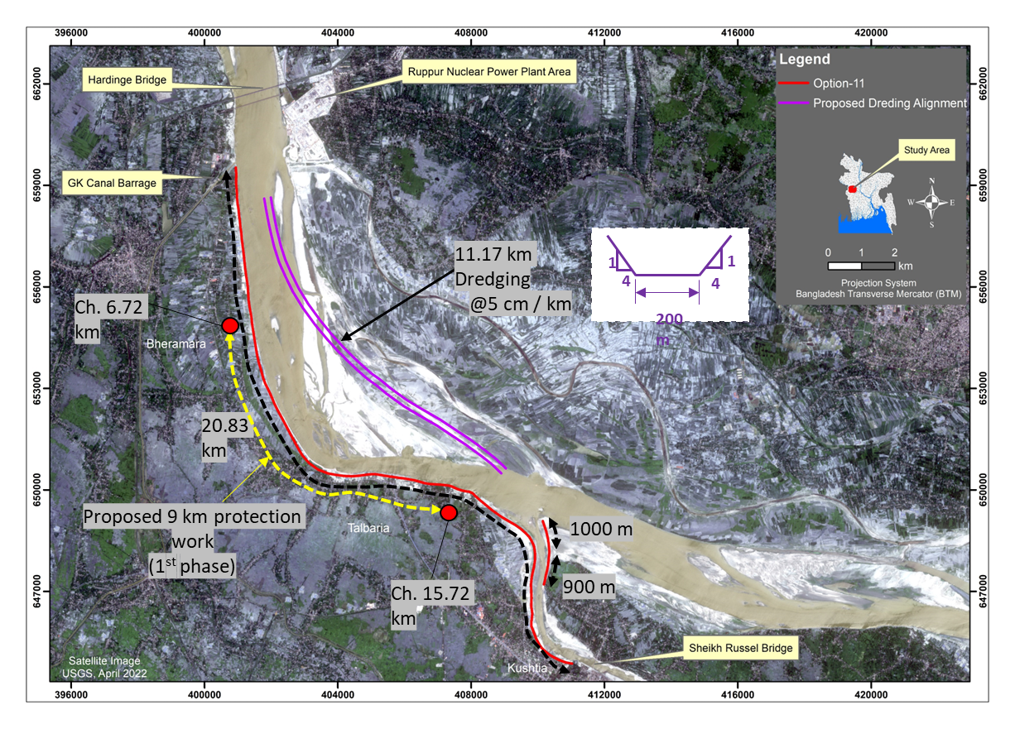

**Figure 6.19** Option-12 incorporating dredging near Talbaria in the Ganges

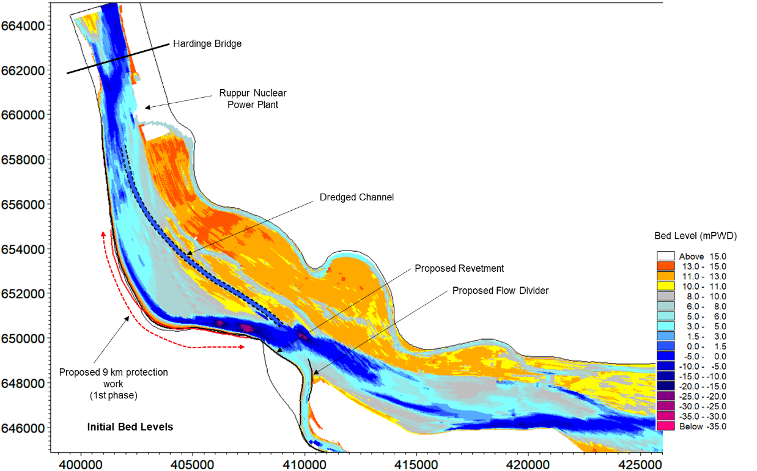

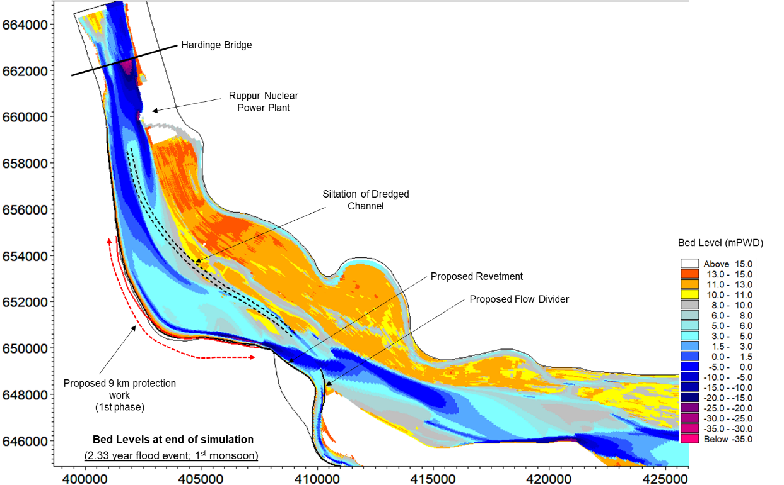

**Figure 6.20** Simulation results (probable bed levels) of Option-12

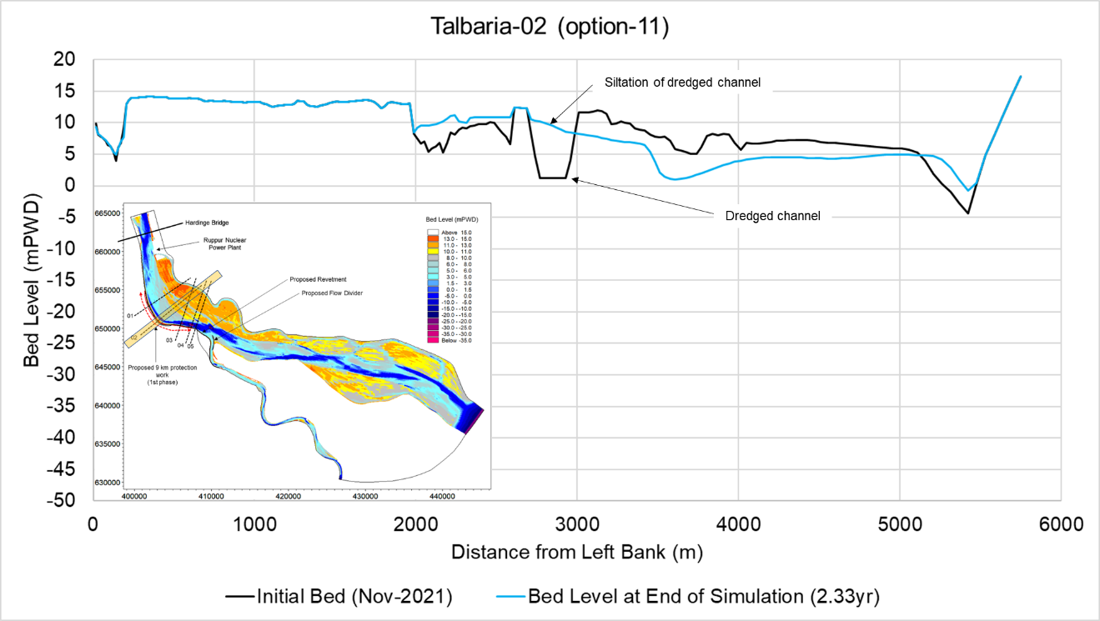

**Figure 6.21** Typical section showing dredged channel silted up.

Table 6.6 Discharge condition during simulation in Option-11

|  |  |  |  |  |
| --- | --- | --- | --- | --- |
| **Time** | **Discharge at Gorai Offtake(m3/s)** | | **Discharge at Hardinge Bridge** | |
| **Monsoon (2nd September)** | **Dry (20th March)** | **Monsoon (2nd September)** | **Dry (20th March)** |
| Base | 4545 | 0 | 42288 | 956 |
| 1st Year | 4533 | 0 |
| 2nd Year | - | - |
| 3rd Year | - | - |
| 4th Year | - | - |

Table 6.7 Discharge diversion through the Gorai

|  |  |  |  |
| --- | --- | --- | --- |
| **Time** | **Flow diversion through Gorai Offtake (%)** | | |
| **Monsoon (2nd September)** | **Dry (20th March)** | **Probable average in 20th March (3yrs simulation)** |
| Base | 10.75 | 0.00 | 0.0 |
| 1st Year | 10.72 | 0.00 |
| 2nd Year | - | - |
| 3rd Year | - | - |
| 4th Year | - | - |

## Probable Morphological Condition near Shelaidah

The most suitable option (option-11) has also been investigated for its impact on further downstream reaches of the Ganges River upto Sengram. Investigation of model results indicate bank erosion threat along a stretch of around 5.25 km at the right bank near Kamorkandi of Shelaidah Upazilla. **Figure 6.22** shows the probable bed levels around the mentioned area. Probable cross-sections at this area are also shown in **Figure 6.23**. Simulation results indicate probable bank erosion threat and presence of deep scour hole (near bank bed level around -22 to -34 mPWD) at the right bank near Rabindra Kuthibari, Komarkandi, Shelaidah which is around 650m away from the river bank.

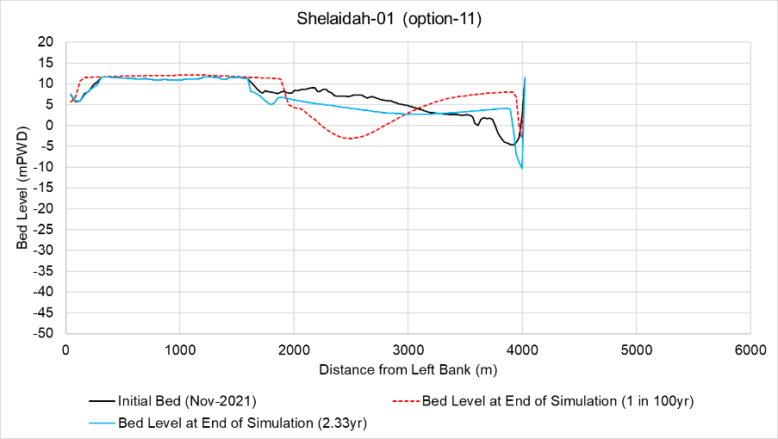

RB

Erosion threat at right bank

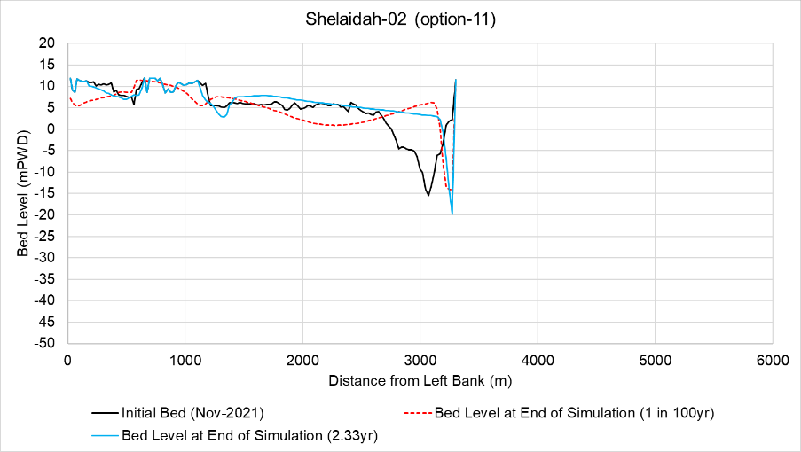

Erosion threat at right bank

RB

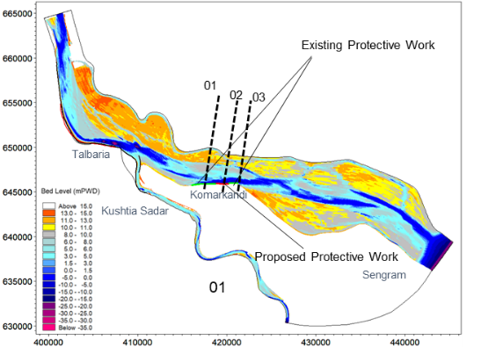

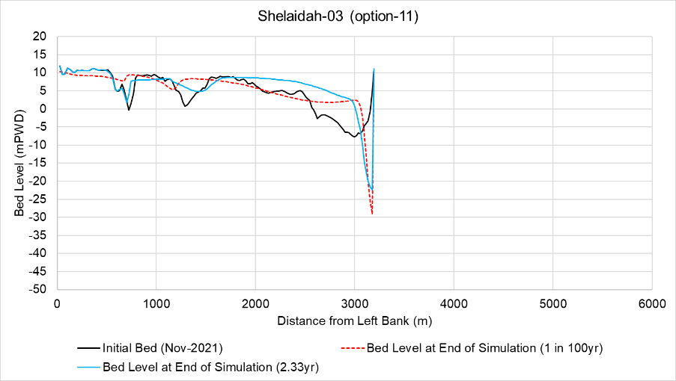

Erosion threat at right bank

RB

**Figure 6.22** Simulated Probable Cross-sections (after implementation of Option-11) near Shelaidah for Average Flood Event

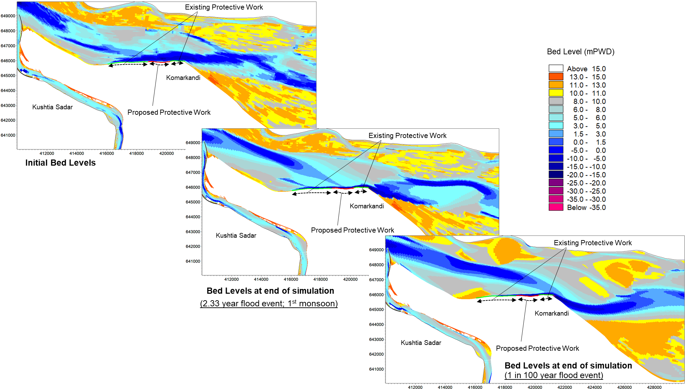

Minimum bed level

-23 mPWD

Minimum bed level

-34 mPWD

Vulnerable Reach

Vulnerable Reach

**Figure 6.23** Simulated Probable Bed Levels (after implementation of Option-11) near Shelaidah

# RECOMMENDATIONS

In context of the above sections, both option-9 (groynes) and option-11 (revetment) along right bank of Talbaria have been found to be the mostt suitable in terms of Talbaria protection and increasing dry season flow through Gorai Offtake. However, obtaining a single solution of the mentioned problem depends on various factors such as field condition, post-construction maintenance, availability of fund etc. For this reason, a decision matrix has been prepared and presented in **Table 7.1** below.

Table 7.1 Decision matrix for selecting most suitable option for Talbaria protection and dry season flow through Gorai Offtake

|  |  |  |  |  |  |  |
| --- | --- | --- | --- | --- | --- | --- |
| **Most Suitable Option** | **Impact on Parameters** | | | | | **Remarks** |
| **Protection of Right Bank of Talbaria** | **Average Flow Diversion (%) through Gorai Offtake**  **(Passing 03 consecutive dry seasons)** | **Approximate Construction Cost**  **(Crore Tk.)** | **Construction Difficulties at Field** | **Vulnerability of Proposed Intervention** |
| Option-9 | Yes | 8.65 | 4000.00+ | Relatively Difficult and Challenging | High | Groynes at Talbaria |
| Option-11 | Yes | 7.67 | 1808.87 | Relatively Easy | Moderate | Proposed Revetment at Talbaria for 1st phase & Proposed Revetment (new + strengthening) at Shelaidah |

From the decision matrix presented above, it is evident that Option-9 (groynes) along right bank of Talbaria is the best suitable option for mitigating the two mentioned problems of the study area. But, due to the presence of a very deep channel (bed level around -30 mPWD, as measured in November-2021), construction of groynes involves major challenges such as design, construction (time and cost), maintenance etc. Regarding to these factors, although revetment along right bank of Talbaria (option-11) along with a flow divider at the mouth of Gorai Offtake may increase comparatively less amount of dry season flow (7.67% as compared to 8.65% in option-9) through Gorai, option-11 can be considered alternatively as the combined solution. Field implementation of option-11 can be done as follows:

* As an emergency measure, nine (09) km of the proposed revetment at Talbaria (starting from chainage 6.72 km to chainage 15.72 km) should be constructed in the first phase on priority basis. In addition, about 1.53 km long bank protection work near Shelaidah is suggested from chainage 7.97 km to chainage 9.50 km which should be included in the first phase of construction work.
* Subsequently, as implementation of option-11 (bank revetment and flow divider) in the upstream (Talbaria and Gorai Offtake) may impose serious threat to the right bank near Komarkandi, Shelaidah, strengthening of existing bank protection work is also suggested in two segments starting from chainage 5.25 km to chainage 7.97 km and chainage 9.50 km to chainage 10.50 km in the first phase.
* In the second phase, at first, construction of revetment at Talbaria should be carried out from chainage 1.50 km to chainage 6.72 km and secondly from 15.72 km towards further downstream.
* After implementation of first phase of protection works, the starting point and ending of existing protection works at right bank of Ganges near Shelaidah (chainages 5.25 km and 10.50 km) should be kept under close observation. Besides, the probable vulnerable reach from chainage 10.50 km to 20.50 km should also be monitored closely. If any bank erosion is observed, proper measures (temporary/permanent) should be taken accordingly.
* To prevent bankline shifting and considering manufacturing time of C.C. block, interim protection work may be done as per **Appendix-A** of this report.

The above-mentioned implementation plan is also presented in **Figure 7.1** and **Figure 7.2** below. Detail design and drawing of option-11 is presented in **Appendix-A**.

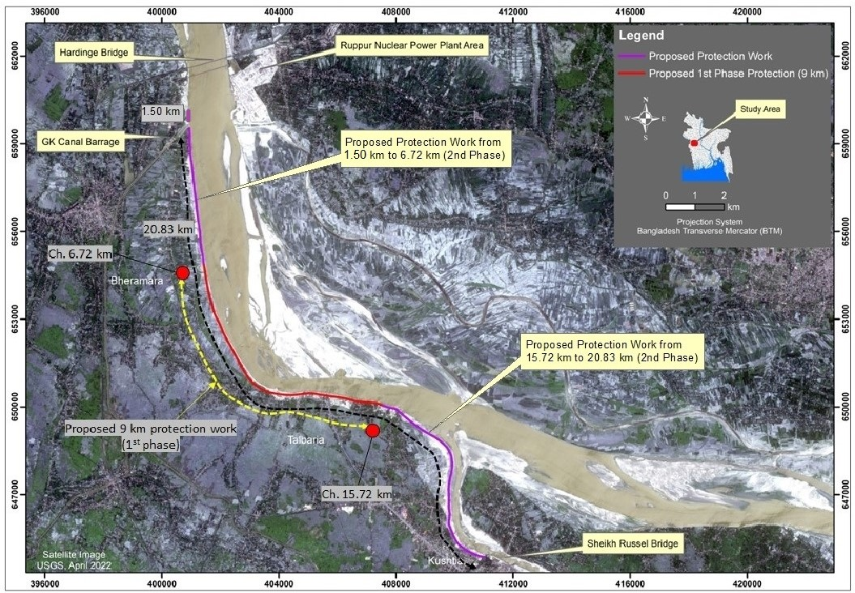

**Figure 7.1** Implementation Plan of Proposed Revetment at Talbaria

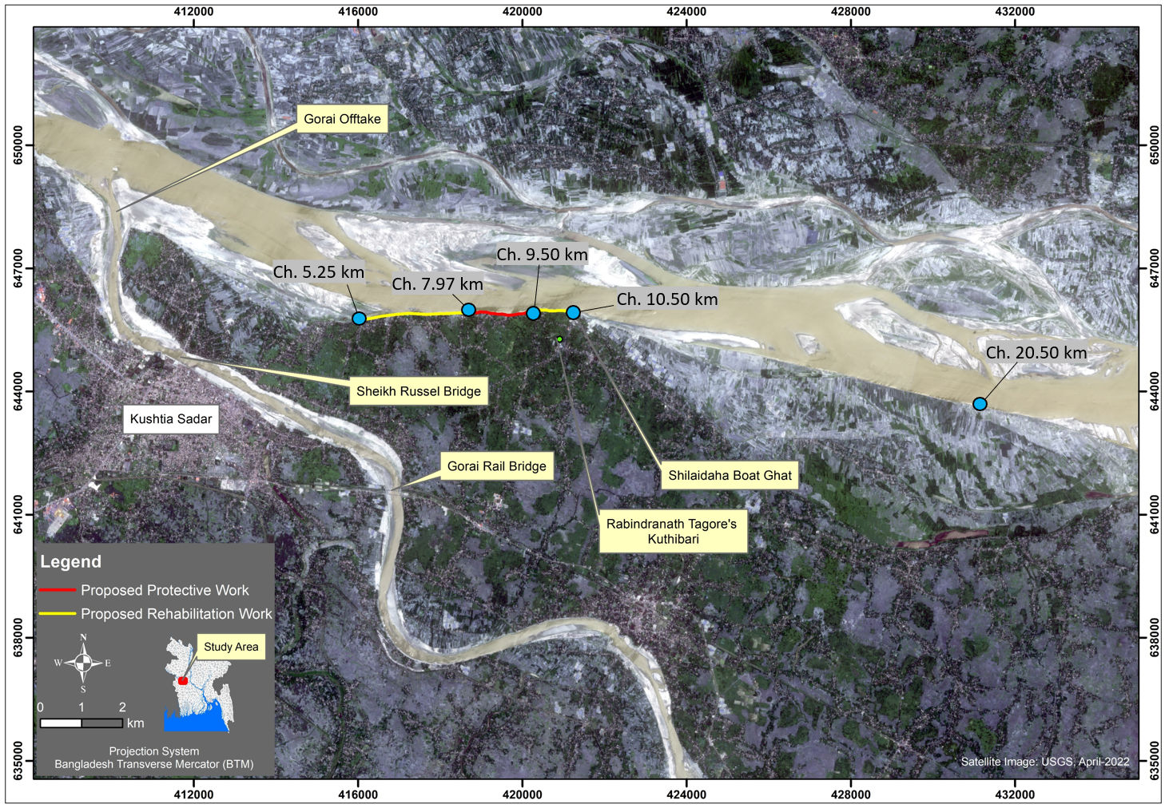

**Figure 7.2** Proposed and Existing Revetment near Komarkandi of Shelaidah

